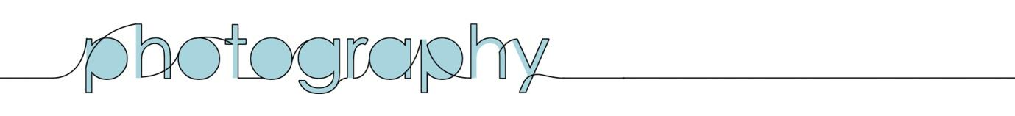
Transition Booklet

Photography /fəˈtɒɡrəfi/ (noun)

…The word "photography" was created from the Greek roots φωτός (phōtos), genitive of φῶς (phōs), "light" and γραφή (graphé) or "drawing", together meaning "drawing with light".

Introduction:
Since its invention in 1839 the process of image making has revolutionised the way in which we communicate through visual media. In modern times the art of photography has become an integral part of our vocabulary and society, imagery overtaking the written and spoken word as the most commonly used communication tool commercially and socially.

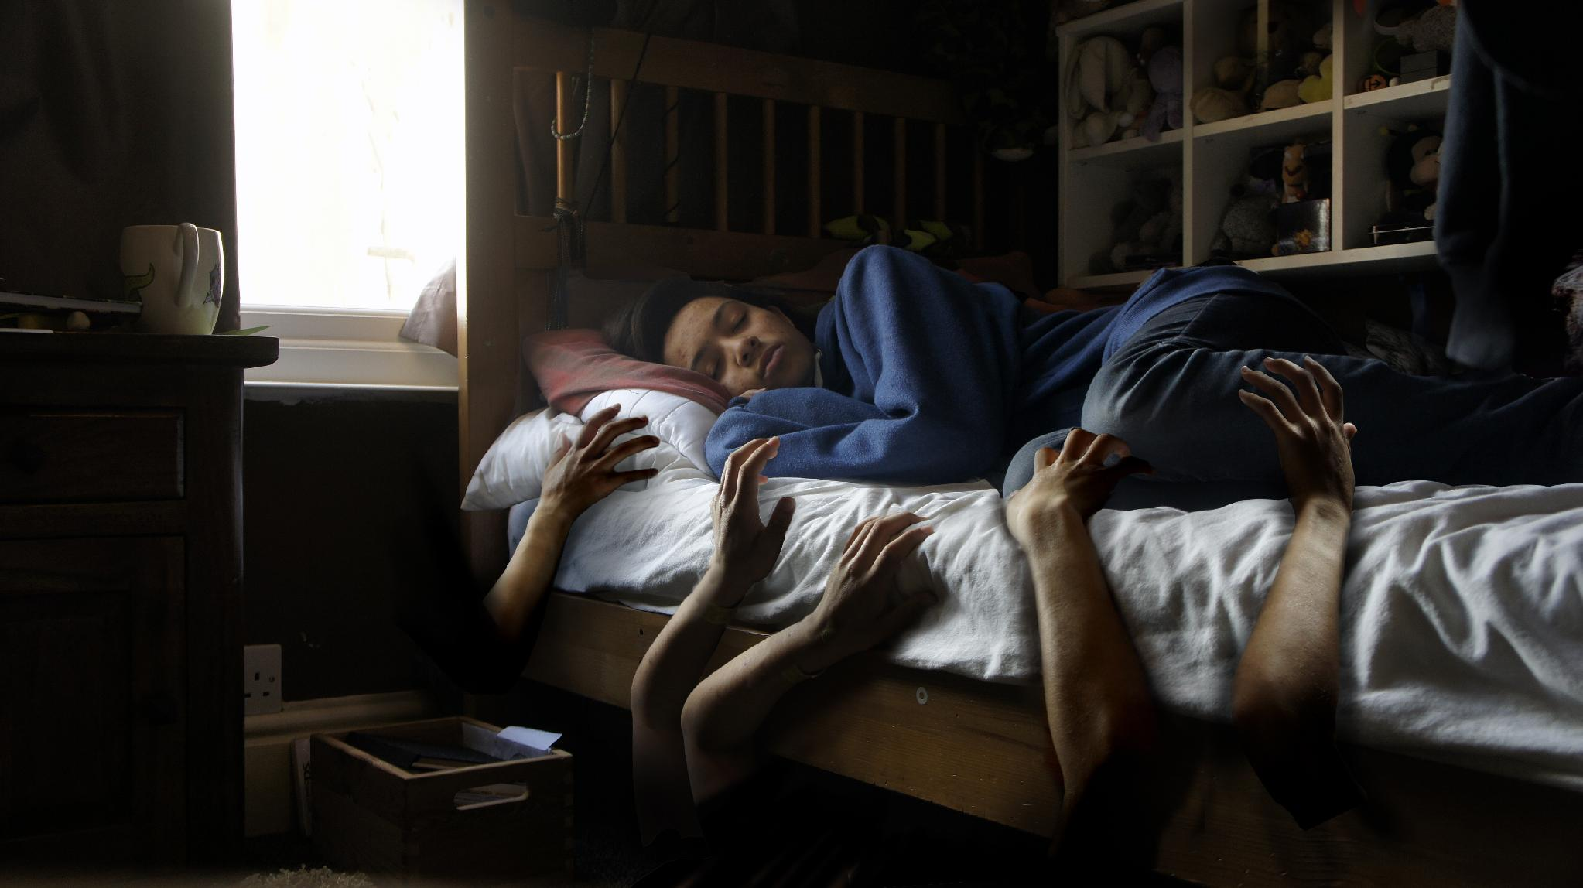

Photography A Level, under the Art and Design Specification, is an opportunity for students to widen their visual vocabulary and become confident in expressing yourself through visual media. Students will learn new photographic techniques, learn how to master the camera as well as studio equipment and digital editing in Photoshop. They will use these skills to develop and produce their own work, developing their ideas and creative expression.

Throughout the year you will be expected to work independently on your work, organising shoots outside of school or travelling to locations, to create new and exciting work.

In this booklet you will find information about the course’s assessment, contents, equipment advice and the transition work. All the courses content is online at https://lkirkby9.wixsite.com/website

Looking forward to seeing you and your transition work in Sept!

Miss Kirkby.

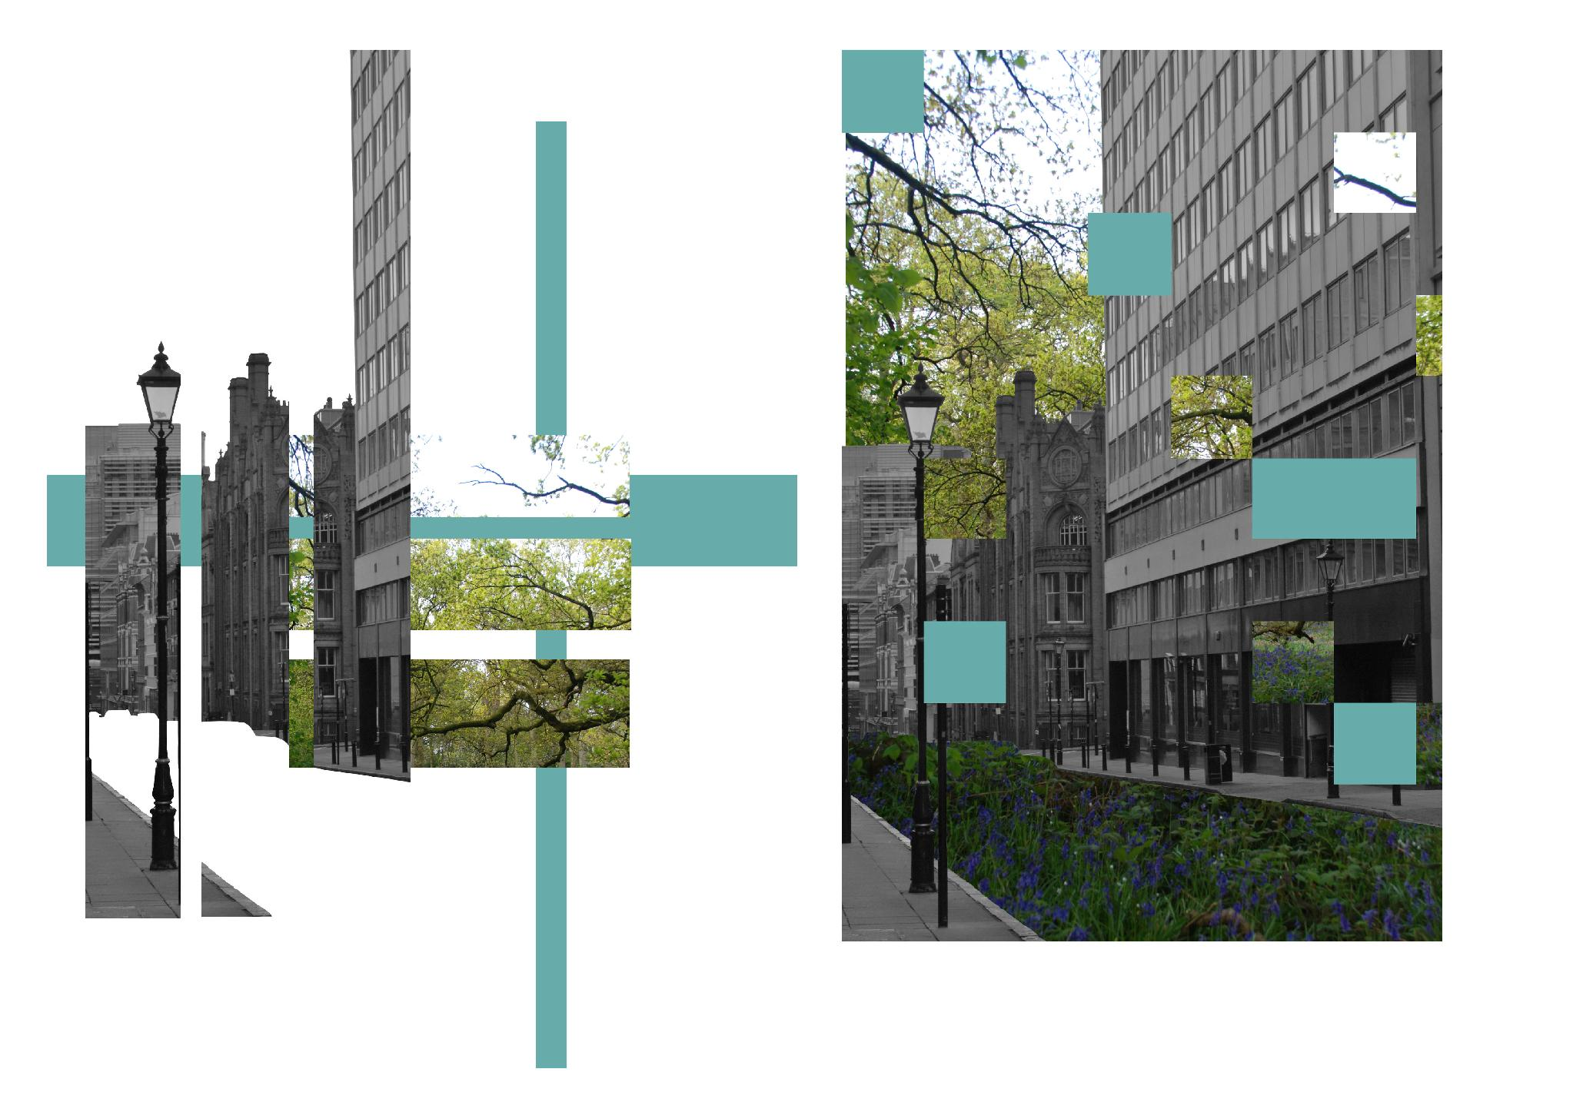

Course Structure:
The 2 year course involves an initial introduction period where you will learn mastering the camera, digital editing using Photoshop, studio lighting, artist analysis and how to develop your own personal work.
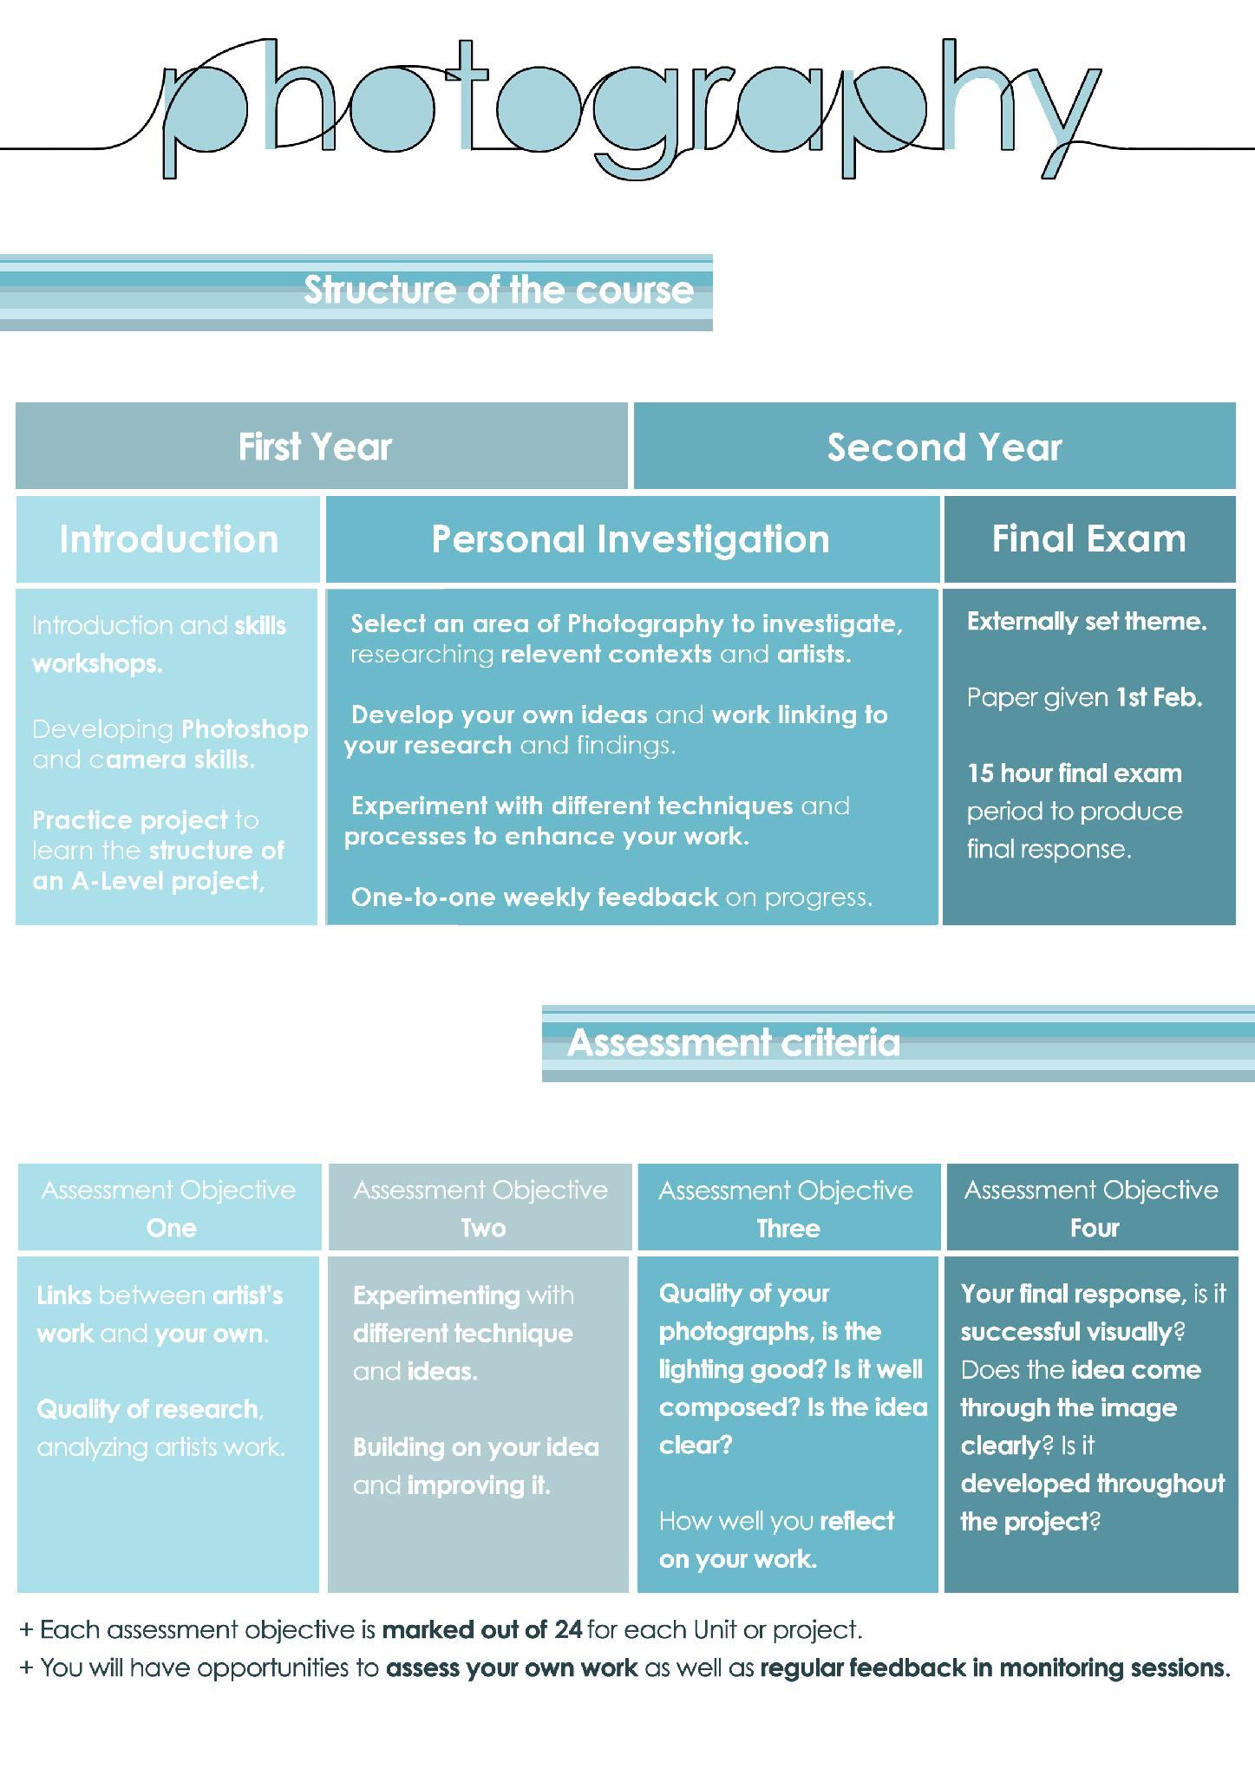

Assessment:
Throughout the course you will receive regular verbal feedback from teachers about the progress of your work as well as advice on how to develop and improve. These informal discussions occur in every lesson alongside regular class wide crits, where the class discuss each work and offer advice.

You are formally assessed against the four ‘assessment objectives’, which will be discussed at the beginning of the course and throughout. It is important you understand these and ensure that your work and overall project answers them as best as you can.

Equipment:
Although we have a series of cameras, tripods and equipment available for students to borrow throughout the course, having your own, although not essential, would help you in producing work. If you are going to purchase your own equipment you can follow this guide, however you are more than welcome to shop around. If you have any questions feel free to email me (lkirkby@nsg.northants.sch.uk)
- Cameras:
  - You need to aim for a “Fully manual DSLR” to allow you to take control of all aspects of the camera when producing work.
  - Canon and Nikon are the most popular brands, however these are not the only ones.
  - A popular and cost effective model past students have used are the Canon 1000 series (Canon 1000d, 1100d, 1200d etc).
  - Buying second hand from Gumtree or Ebay can be a real money saver, and please do go look for a bargain! But please beware of scams and ensure you go with your parents if you travel to collect an item. Check it is working before paying for it and if you are not sure, walk away! (If you want me to check over a potential purchase feel free to send me a link and I will have a look for you

- Memory card for your camera:
  - Unless you buy a second hand camera with one bundled in you will need a memory card to store your images on.
  - These can be brought from online retailers, like Amazon, as well as various supermarkets.
  - You should aim for at least 2Gb/4Gb.

- Memory Stick:
  - As we are a digital course this is a crucial piece of equipment to store your work on and bring it to school. (We also use Google Drive to ensure it is backed up!)
  - You can get these in various sizes, but recommended is 4Gb or more. You can purchases them from various outlets, cheapest being supermarkets or Amazon.
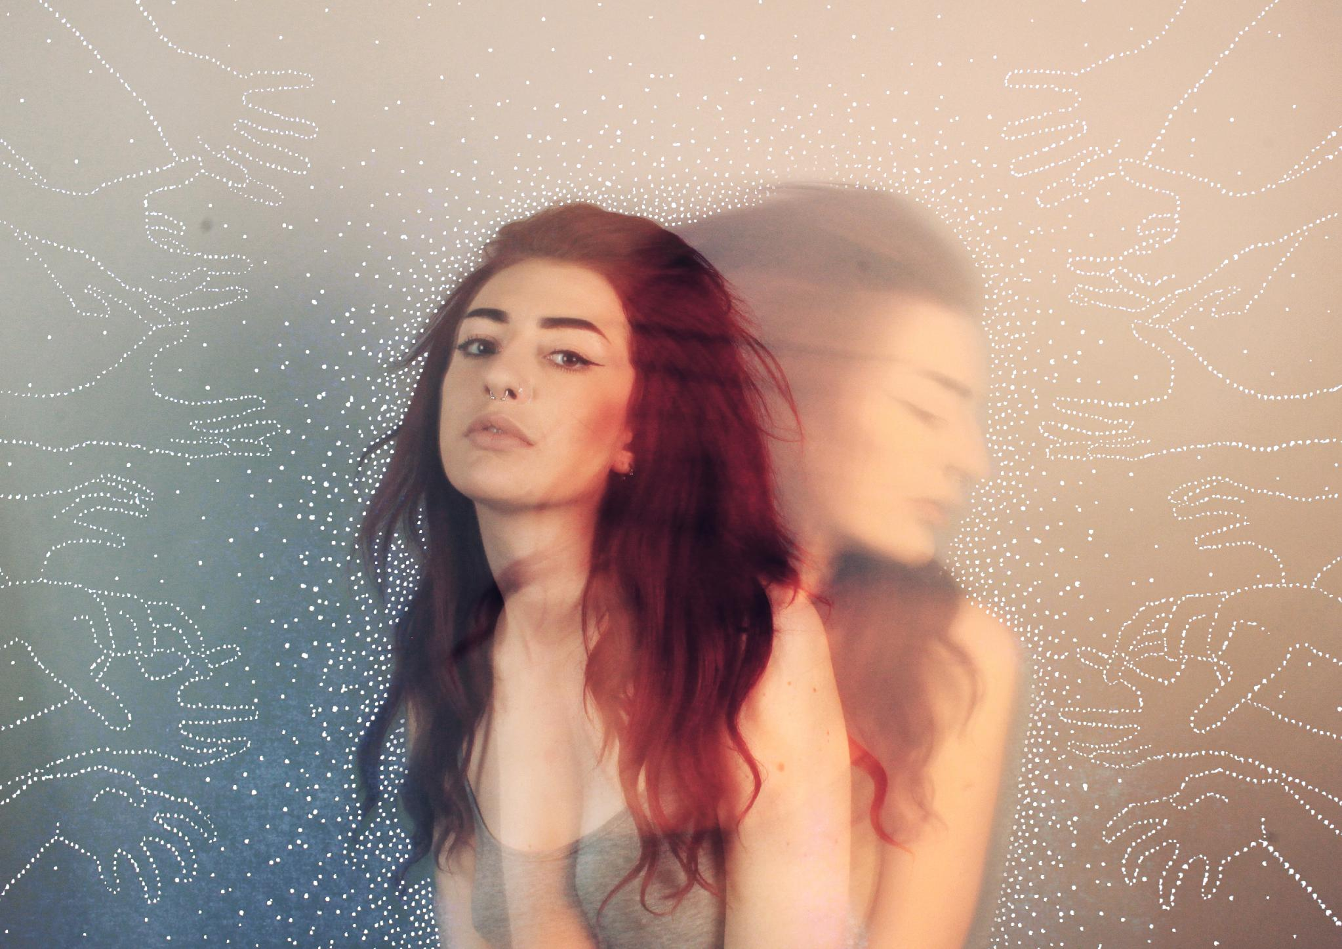
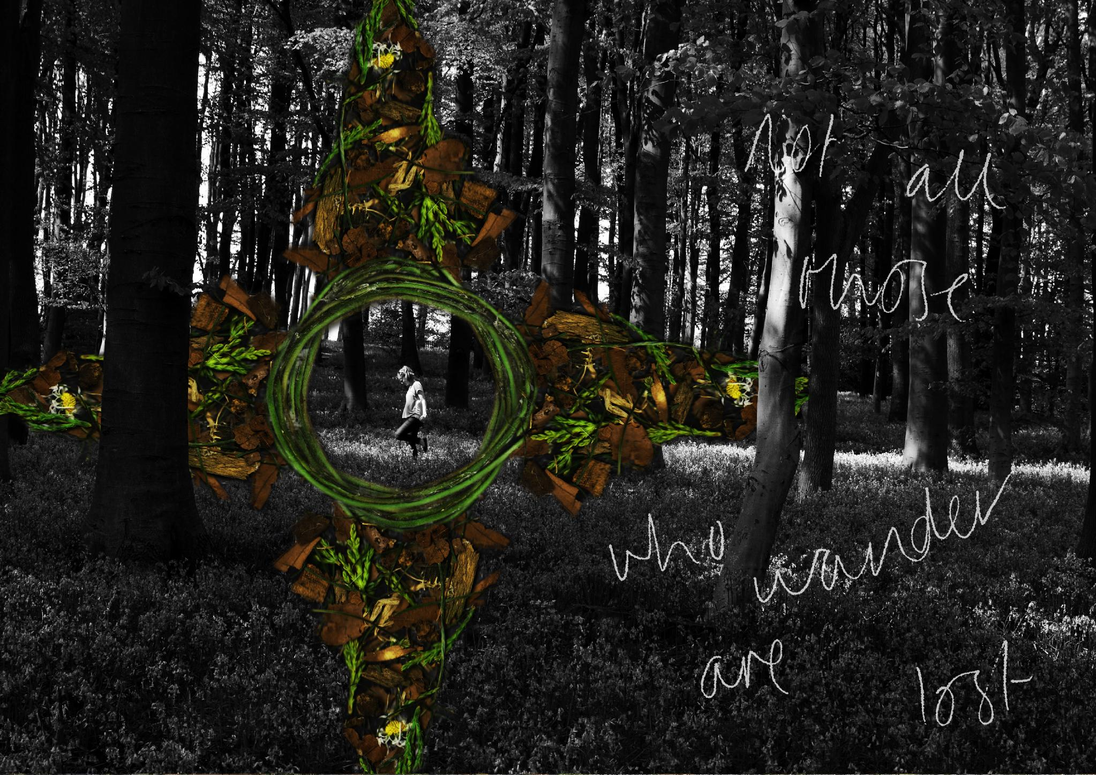

Assignment: Transition Task

Journey (noun)
…An act of travelling from one place to another.

Aim: To prepare you for A Level Photography, tasking you to think carefully about what, how and why you photograph scenes with a clear theme and artist influence.

Practical work: You are required to:
- Go online to https://lkirkby9.wixsite.com/website, click on “Assignments” then the first assignment titled “Journey”.
- Select one artist from the photography website that inspires you, or you can discover your own through links on the Photography website.
- Produce at least six images, either individual or a set, which explores the concept of a ‘Journey’.
- Think carefully about composition, what is in your frame as well as lighting. Avoid obvious and cliché ideas.

Presentation: How to present your work:
- Create a title “Journey” with a brief explanation of the task. Include how you interpreted the theme.
- Present your chosen photographer on one page, examples of their work as well as analysis on them and your favorite piece of their work. (Use the “How to…analyze artists” guide to help you)
- Ensure you use visual strong examples of their work. Try to avoid ‘small’ Google images, as they can become pixelated, which looks awful!
- Print off your images professionally (6x4) and present them very neatly in your book.
- Analyse your own work, discussing its success and interpretation of the theme. (Use the “How to…present a shoot” guide to help you)
- Use clear and concise language with terminology when appropriate.

Deadline: When should I hand it in?
- Deadline: First lesson back!


