
Spinney Hill Road, Northampton. NN3 6DG
Tel: 01604 679540
Email: admin@nsg.northants.sch.uk
Website: www.nsg.northants.sch.uk

Headteacher: Mrs Cristina Taboada-Naya

L’introduction du français
au niveau A-Level.

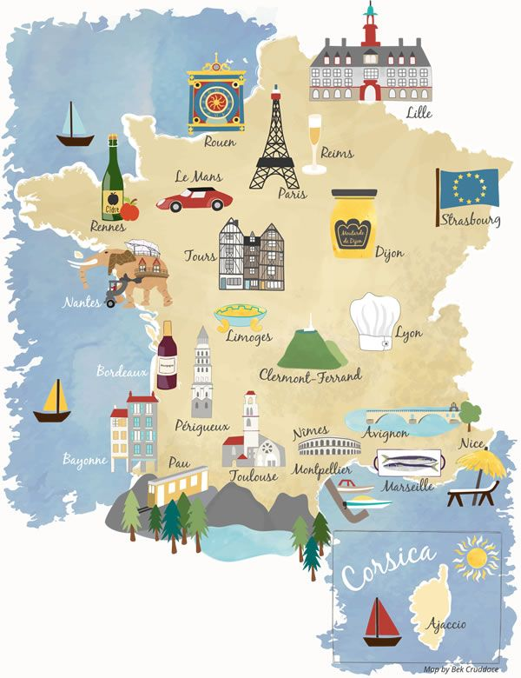


Travail d’été
Why should I pick French at A Level?

French is a key global language
Being able to speak French can provide you with travel and work opportunities. In fact, according to the British Council’s 2013 report ‘Languages for the Future’, 49% of UK businesses look for employees who can speak French, meaning studying the language will be a huge asset to your career

Gap Year and Travel Opportunities with French
Studying French at A-Level, not only improves your language skills, but it provides you with insights into France’s history and culture. If you do plan on travelling after school, this knowledge will truly enhance your experience.

What Other Subjects Go with French?
Given its cultural history, French also goes well with subjects such as Philosophy, Music and Theatre, and most arts-based study areas. Psychology, Economics, Business, Science and History are also subjects you could consider pairing with French.

What am I going to study ?

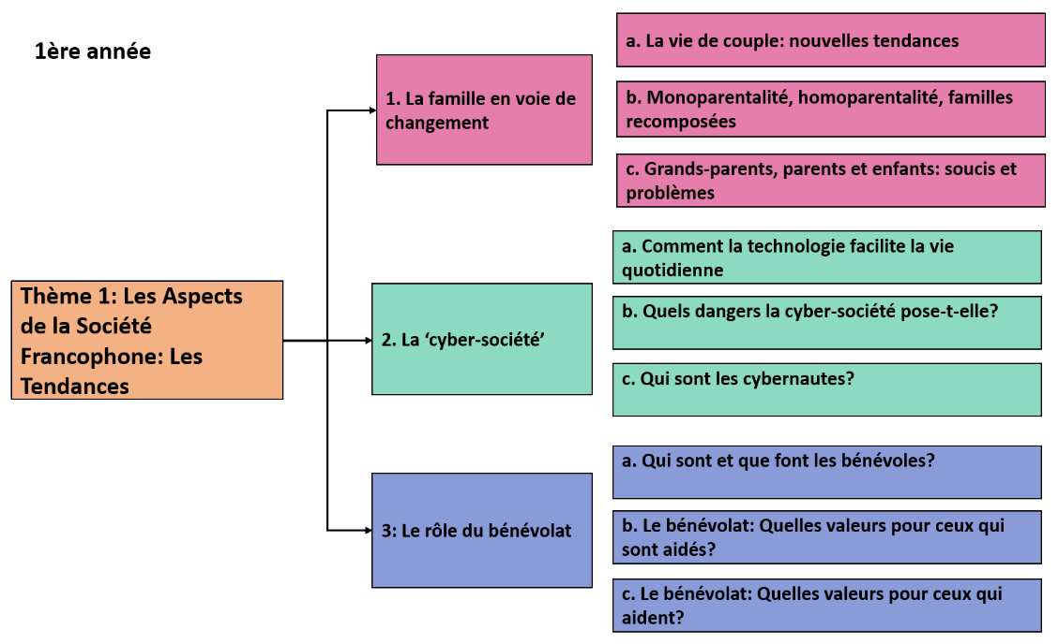
AQA Year 12

Topic 1: Changes in family
Topic 2: Cyber-society
Topic 3: Volunteer work

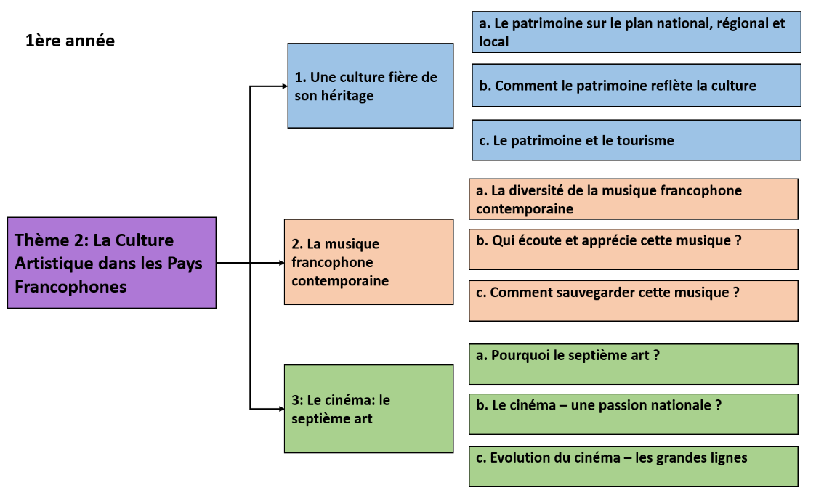

Topic 1: Culture and heritage
Topic 2: French modern music
Topic 3: Cinema

AQA Year 13
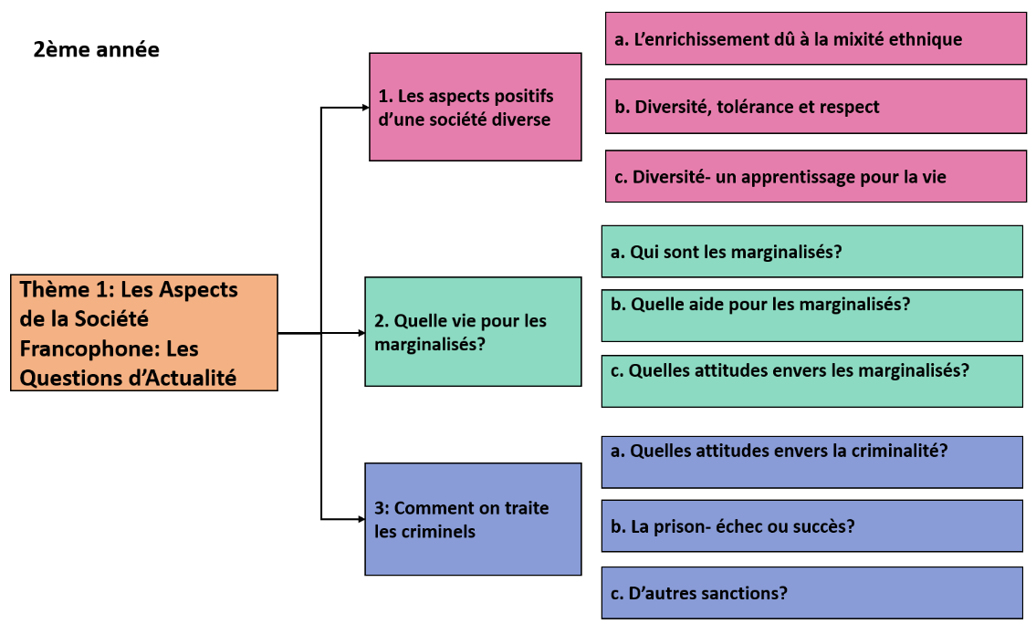

Topic 1: Positive aspects of a diverse society
Topic 2: Life for the marginalised people
Topic 3: How criminals are treated

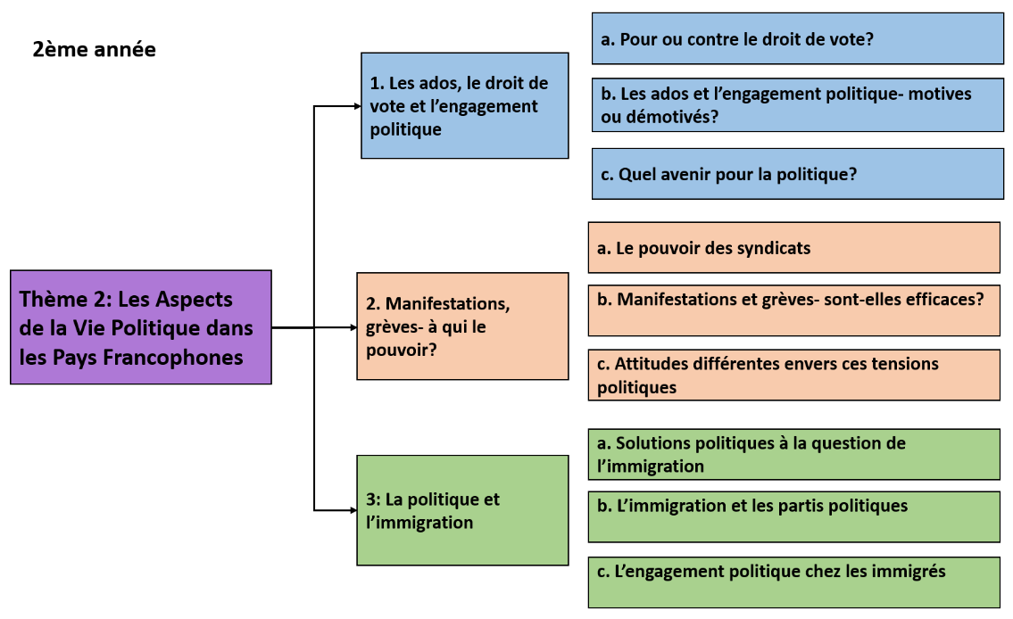

Topic 1: Teenagers, voting rights and political commitment
Topic 2: Strikes and demonstrations
Topic 3: Politics and immigration

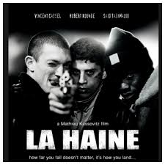

Film study
La Haine, directeur, Mathieu Kassovitz (1995)

Book study

No et moi, Delphine de Vigan (2009)

How am I going to be assessed ?

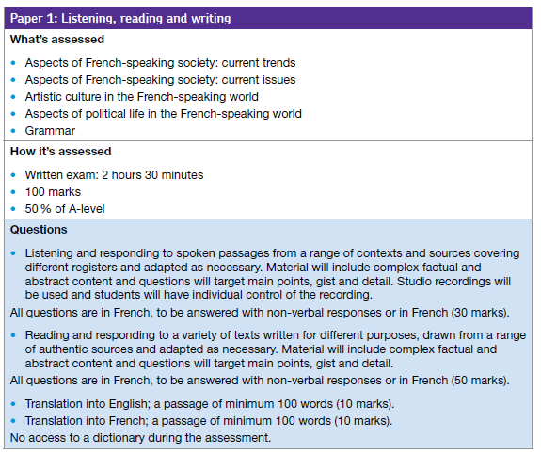
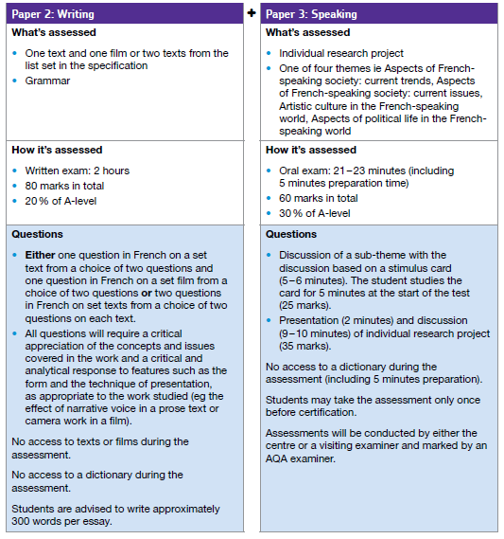

How to prepare for French at A Level

You have a few weeks to really prepare for your A Level in French. The leap from GCSE to A Level is significant. This booklet contains links to a huge range of media, most of which is available for free online as well as tasks to complete before the start of term. In order to keep pace, it is vital that you work through the tasks. Little and often…
First thing you could do is switch to French browsers such as www.google.fr or www.yahoo.fr . This way, you will read French every time you log on and it will become part of your everyday activity.

Television
- http://www.tv5monde.com/ Watch this channel to gain access to the last episodes of all of their TV shows. Check out their French language learning section at http://apprendre.tv5monde.com/ where you can watch clips and answer comprehension questions on what you have seen with accompanying grammar exercises.
- Download an app called 6play on your device (if possible) – search in the App Store for M6. This is a popular French TV channel. Not all programmes are available outside of France, but there is a good selection and these help with listening skills.
- Look at the BBC website http://www.bbc.co.uk/languages/french/tv for links to French programmes available on line.
- If you have a Netflix or Amazon Prime account, try searching for “French language films” or simply “French language”. Several films are available to watch but may not pop up onto your feed.
- http://www.tv5monde.com Watch this channel to gain access to the latest episodes of all their TV shows. They also have a French language learning section at http://apprendre.tv5monde.com where you can watch clips and answer comprehension questions on what you have seen with accompanying grammar exercises.

Youtube channels
- https://www.youtube.com/channel/UCl0u_YK8kwwZanklN6W-3tg Ca commence aujourd’hui is a French talk-show about social issues where people are invited to testify and share their experiences and opinions. Great to stay in touch with current issues.
- https://www.youtube.com/user/BFMTV BFMTV is a French news broadcast with short and long videos on social, political and economic issues in France.
- https://www.youtube.com/user/lexpressmu L’express is another French news broadcast. You can also follow them on Facebook to read their articles https://www.facebook.com/LExpress You can always get notified on the latest news.
- https://www.youtube.com/channel/UCLmlUMA_bGiMWWgfDwfNDgw 1jour 1question is a channel if you want to know more about the history and culture of France.
- Lena Situations for travel and lifestyle
- Visites Privées for French heritage and culture
- Konbini for interviews and pop culture
- Quotidien for interviews and society
- France Info for current affairs and politics
- Bandes Annonces Cinéma for movie trailers in French

Listening skills
You need to keep listening to French often so you don’t get rusty, even though you might not understand everything you hear. While listening to podcasts, videos and songs, you can either choose to focus on vocabulary(words you know/don’t know), topic (what it is about) or French sounds (the letter R or the sound U for example).
- https://www.newsinslowfrench.com/
- https://innerfrench.com/podcast/
- MFL clips with audio & subtitles on Facebook.
- http://zut.languageskills.co.uk/advanced/year12.html This website is free after 4pm and really comes into its own with its A level section. Watch news video clips, find theme related vocabulary and do listening and reading comprehensions.
- https://www.radiofrance.fr for a range of podcasts; https://www.chantefrance.com for French-spoken songs https://fr.lyricstraining.com/fr for lyrics of French-spoken songs

Reading skills
Keep your own vocabulary book for new expressions you come across. You could order it alphabetically, by topic area based on what we are going to study or just use it as a diary and scribble away your French development in it.
- Le Figaro is available in larger paper shops. Le Figaro has its own website http://www.lefigaro.fr/ so that you can read the paper online. You do not have to read the paper cover to cover, just scan the headlines and pick out ONE article that grabs your attention.
- https://www.1jour1actu.com/ which you can find easy articles to read on varied topics.
- http://www.mediatico.com/en/newspapers/europe/france/national/
This website gives you access to newspapers all over the world. Here is the link to a range of French papers.
- http://www.20minutes.fr. This website is a more light-hearted newspaper which covers global stories as well as gossip. Also try the TV Channel for this newspaper http://www.20minutos.fr/tv/
- To catch up on the latest gossip and to see what the celebs are wearing, take a look at www.elle.fr.
- https://www.lemonde.fr
- https://www.francetvinfo.fr
- Educational websites for French speakers:
- https://www.lumni.fr
- https://www.1jour1actu.com
- https://leco.playbacpresse.fr

Websites for research
Once you actually start your A Level in September, you will realise that you are almost completing a Sociology A Level in French. It is fascinating and you will learn all about the history and culture of French speakers. Here are some websites bursting with information about France and Francophone countries. Always start your research with these websites as it is easy to get bogged down when looking for help on the internet.

If you are searching for information, try switching to the French www.fr.wikipedia. Remember that anyone can write on Wikipedia so you

must validate your research elsewhere and never quote from it! It is a good place to start though.

A French government run website: http://www.gouvernement.fr/

A website in English with some great links to various topics: http://french.about.com/

British Council support available from http://schoolsonline.britishcouncil.org/ Keep your eyes peeled as they often have trips to France for free! You have to apply for them but they are an amazing opportunity to build your French skills. There is no better way to learn a language than by spending time in that country.

Browse Instagram, TikTok… to find accounts dedicated to the learning of the French language. Use hashtags like these to find relevant accounts:
#French
#learningFrench
#lefrançais
#grammairefrançaise
#j’apprendslefrançais

Online dictionary
- http://www.wordreference.com/
- https://www.linguee.fr/

Independent Learning A Level French

- Revise vocabulary every week and create a bank of idioms/authentic expressions to elevate your speaking and writing skills.

- Create a grammar book in which you will list the areas you feel less confident then quiz yourself online: it is very easy to find various tests online (BBC Bitesize for example). Practise makes perfect!

- Print a copy of the syllabus and as you go through each topic, create revision cards/mind maps. You need to break things down into ordered targeted small sections.

- Check, study and complete past papers to improve your work. Get accustomed to the type of questions and language you will face in the exam.

- Read the examiners’ report for all skills. The exam boards make public a document written by examiners in which they state what they like to read and also give examples of what not to do.

- Get as much “contact time” with the language as you can. You can watch French films, Netflix in French, videos on Youtube, listen to podcasts or Spotify. Also, you can switch your favourite English TV shows in French audio with/out French subtitles.

- Speaking practise with your friends or family: agree you will only speak French together at lunch every day. Even 15 minutes a day, that’s over an hour of extra practise.

- Watch the news, social media and make notes of French issues – record key case study details (what, where, when, who, why, vocabulary) and link it to the syllabus.

- Set up Google alerts to be notified of key new articles straight to you Gmail account. Stay in touch with what is happening in the French-speaking world.

- Set up a short-term, mid-term and long-term revision calendar in order to organise your time effectively.
What I need to revise
- Nouns: gender and numbers.
- Articles: definite, indefinite and partitive.
- Adjectives : position, agreement, possessive, comparative, superlative and demonstrative.
- Adverbs.
- Relative pronouns.
- Present tense regular and irregular verbs (être, avoir, aller, faire, devoir, pouvoir, vouloir).
- Perfect tense regular and irregular verbs.
- Imperfect tense regular and irregular verbs.
- Near future tense.
- Simple future tense regular and irregular verbs.
- Conditional tense.
- En + participle present
Links to Grammar Practise exercises
- The Grammar Revision resources on www.languagesonline.org.uk are great as you can then select what tense you want to revise, read the explanations and complete the exercises. You can do these as often as you like and it gives you a percentage. Another useful tactic is to translate the examples and exercises into English to ensure you understand the meaning of each tense.
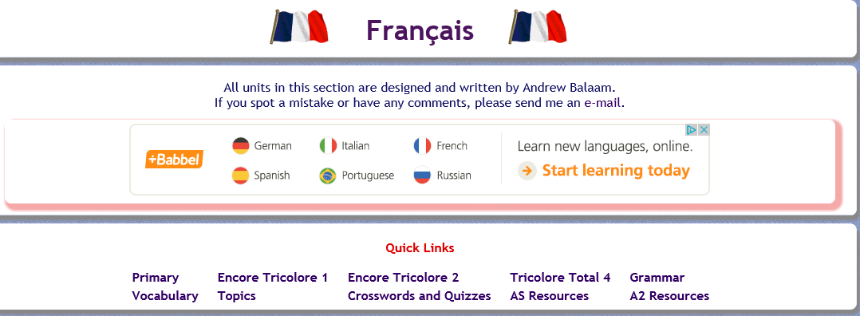

Either choose to practice your grammar or work through some of the AS Resources.

- https://conjuguemos.com/ a great website for practicing your verb conjugations.

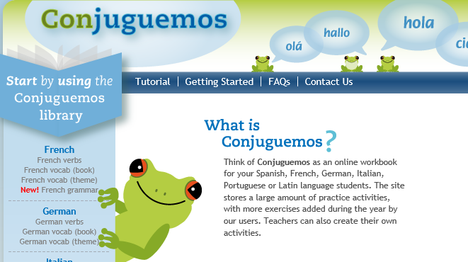
. Click here to access the French verb exercises

- http://zut.languageskills.co.uk/advanced/year12.html. A website is free after 4pm and really comes into its own with its A level section. Practice your verbs, pronouns, do practice translations and review other grammar points.
- https://www.bbc.co.uk/bitesize/subjects/z9dqxnb BBC Bitesize with videos and tests.

Summer work

- Complete the grammar revision booklet (Appendix 1). Do not rush to complete the review, this is not a race, understanding and mastering takes quality time.

- Please research an aspect of contemporary French society. This can be a news item, for example an event that happened in France this year. It could also be a French song or film that you enjoyed or that has been popularised globally. You will need to prepare a speaking presentation, to be presented entirely in French. You can use a power point containing keywords, facts, pictures and short videos (if necessary) and handouts. It should last between 1-2 minutes. In your presentation, you must include all of the following bullet points:
-The name of your topic/subject.
- Reasons why you chose this topic.
-The what, where, when, who, how questions. -Why is your topic important/relevant in French society?
3. Learn and practise the vocabulary of the first two topics from the course : La famille en voie de changement and La cyber-société https://quizlet.com/NA-MFL/folders/sixth-form-aqa?x=1xqt&i=xz96y

Appendix 1 – Grammar Revision
Les noms nouns
Check out the following website, then answer the questions:
https://www.bbc.co.uk/bitesize/guides/zvr7382/revision/1
- Circle the nouns in the list:

tante
jouer
intéressant
Rouge
dix-sept
salade
finir
chaise
sac
manger
parc
super

- There are some the rules that help us work out the gender of nouns. Looking at the ending of these nouns, categorise them into masculine and feminine.

promenade
château
racisme
télévision
vedette
natation
nourriture
bâtiment
circulation
tourisme
oncle
l’habitude
médicament
l’eau

Les articles Articles
Check out the following website, then answer the questions:
http://www.bbc.co.uk/education/guides/zyynsbk/revision
Definite articles
- What is meant by definite article? ___________________________________________________________________________________________________________________________________________________________________________________________________________________________
- What are the French definite articles? (there are 4) ________________________________________________________________________
- When is the definite article used in French but not in English? (at least 2 examples) __________________________________________________________________________________________________________________________________________________
- Choose the correct definite article: le /la/l’/ les
  - _____ garage est vide.
  - _____Allemagne est près de la France.
  - ____voiture est verte.
  - ____ parc est génial.
  - _____ terrorisme me fait peur.
  - Mon frère s’est cassé _____ jambe.
  - ___argent donne ____ liberté.
  - ___hôtel est impressionnant.

- Translate the following sentences into French, remembering to use the correct definite articles.

- I have green eyes and freckles
______________________________________________________________________________________________________________________________________________________
- He likes swimming but doesn’t like horse riding
______________________________________________________________________________________________________________________________________________________
- Marcel finds French difficult
______________________________________________________________________________________________________________________________________________________
- She brushes her hair
______________________________________________________________________________________________________________________________________________________

Indefinite articles
- What is meant by indefinite article? __________________________________________________________________________________________________________________________________________________
- What are the French indefinite articles? (there are 3) _________________________________________________________________________
- When don’t we need to use the indefinite article in French?

- Choose the correct indefinite article: un/une/des
  - Je veux ____ gâteau.
  - Il y a ___ grand fauteuil dans le salon.
  - Tu as ___ chiens ?
  - Je voudrais lire ____ magazine sur la mode.
  - Il porte ____ chaussures noires.
  - Ils ont ____ belle voiture
  - Elle travaille dans ____ restaurant
  - Il y a _____ fruits dans le frigo.

- Translate the following sentences into French, remembering to use the correct indefinite articles.
- I want a blue bike
____________________________________________________________________________________________________________________
- She wants to read a book on sport
__________________________________________________________________________________________________________________________________________________
- Marcel eats apples everyday
__________________________________________________________________________________________________________________________________________________
- My brother is a nurse
_________________________________________________________________________

Partitive articles
Use the following website to revise partitive articles:
https://www.cliffsnotes.com/study-guides/french/french-i/french-i-articles/partitive-articles
- Complete the grid
 | singular | plural
masculine
feminine

- What is the partitive in English? _________________________________________________________________________
- When is the partitive NOT used in French? (2 options) _________________________________________________________________________
- When is the partitive article changed to “de” or “d’”? Give 4 examples.

- _______________________________________________________
- _______________________________________________________
- _______________________________________________________
- _______________________________________________________

- Translate the following sentences into French.
- My sister takes time when she wakes up. ______________________________________________________________________
- I have some ice cream in the kitchen. ______________________________________________________________________
- I like most fruits and vegetables. ______________________________________________________________________
- He buys some pears every week. ______________________________________________________________________
- She has tea with lemon. ______________________________________________________________________
- My mum does not eat strawberries nor raspberries. ______________________________________________________________________

Les adjectifs Adjectives
Use the following website to revise adjectives:
https://about-france.com/french/adjectives.htm
Position and agreement
Are the following statements about adjectives true or false? Write T or F next to each sentence.

- To form most female adjectives you add “e” to the masculine form.
- All adjectives undergo a spelling change in the feminine form.
- You always add “s” to make an adjective plural.
- Some adjectives come before the noun they are describing.
- If an adjective ends in “e” in the masculine form, you add another “e” to make it
feminine.
- All adjectives undergo a spelling change in the plural form.

- Correct the statements that are false.
_____________________________________________________________________________________________________________________________________________________________________________________________________________________________________________________________________________________________________________________________________________________________________________________________________________________________________________________________________________________________________________________________________________
- Some adjectives precede the noun. You can remember which ones do this using the acronym BANGS. What does BANGS stand for?
_________________________________________________________________________________________________________________________________________________________________________________________________________________________________

- Give at least 5 examples of adjectives which precede the noun. Give the masculine and feminine form of the adjective.
  - ____________________________________________________
  - ____________________________________________________
  - ____________________________________________________
  - ____________________________________________________
  - ____________________________________________________

- Some adjectives can be used before and after the noun(s) they describe, resulting in different meanings. List as many of this type of adjective as you can with their respective meanings.

Masculine form | Feminine form | Meaning when before noun | Meaning when after noun

- Write 5 sentences in French, each one containing at least 2 adjectives. Use examples from the previous exercises.
- ………………………………………………………………………………………………………………………………………………………………………………………………
- ………………………………………………………………………………………………………………………………………………………………………………………………
- ………………………………………………………………………………………………………………………………………………………………………………………………
- ………………………………………………………………………………………………………………………………………………………………………………………………
- ………………………………………………………………………………………………………………………………………………………………………………………………

Comparative and Superlative adjectives
Rearrange the words in the correct order:
- plus intéressante elle que est Marie
- passionnant moins est le sport que la technologie
- je aussi que grand suis Paul
- Sam plus les sports individuels aime les sports d’équipe que

- Translate the following into French
- A difficult pet
- A more difficult pet
- The most difficult pet
- The worst
- The best
- The least
- My sister is more annoying than my bother
- My friends are more selfish than me
- Elise has less money than Marian
- Sebastian has more money than Joseph
Fill in the blanks in these sentences and then translate the sentence:
- Nico est _________________ meilleur chanteur
- Marie est __________________meilleure amie de Cécile.
- Elles sont ___________________pires ennemies
- J’ai ________________plus beau vélo.

Possessive adjectives
Use the following videos to revise possessive adjectives:
- https://www.youtube.com/watch?v=TFCkx4kl5rc
- https://www.youtube.com/watch?v=ebrBZ41R1Cs
- https://www.youtube.com/watch?v=tHh_2s6gI7o

Fill in the table:
English | Masculine | Feminine | Plural
My | Mon | Ma | Mes
Your (singular/informal)
His/her
Our
Your (plural/formal)
Their

- The possessive adjective must agree with the person or the thing you are describing – it doesn’t matter if the person it belongs to is male, female or plural!
- Fill in the gaps with the correct possessive adjective:
  - Her grandmother : ___________ grand-mère
  - Our parents: _________ parents
  - Their brother: __________ frère
  - Your (formal) cousin(m) ____________ cousin
  - Their grandparents: ________________grands-parents
  - His aunt: ______________ tante
  - Her uncle: ________________ oncle
  - Her brothers: ___________________frères
  - Your (informal) sisters: _______________sœurs
  - My friends: ______________amis
  - His girlfriend: _____________ copine
  - Your friend (f): ________________ _____________

Demonstrative adjectives
Demonstrative adjectives = that/those/these and are used before a noun

 | Singular | Plural
Masculie | ce jean  cet avion | ces singes
Feminine | cette fleur | ces bottes

To be more precise you can add ci or là after the noun..
Je voudrais ces fleurs-ci I would like these flowers here
Je voudrais ce singe-là I would like that monkey there
Demonstrative pronouns- they do the same thing but they replace the noun so it’s like saying this one/ that one/ those ones/ these ones. They are often follwed by qui, que or de to say things like ‘the ones who’ or ‘the one that’

 | Singular | Plural
Masculine | celui | ceux
Feminine | celle | celles

You can also add ci or là for emphasis
Je n’aime pas celle-là I don’t like that one
J’adore ceux-ci I love these ones
- Translate the following into French
- I like those trousers but I prefer these ones here
____________________________________________________________________________________________________________________________________________
- I love French designers and I prefer those who use bright colours
____________________________________________________________________________________________________________________________________________

- I don’t like these coats, let’s go to Topshop
____________________________________________________________________________________________________________________________________________

- This band is quite boring, I prefer those with more drums!
____________________________________________________________________________________________________________________________________________

- I don’t like these people and I don’t like those who steal sausages either!
____________________________________________________________________________________________________________________________________________

- Which car do you prefer, this one here or that one there?
____________________________________________________________________________________________________________________________________________

- Those who eat haribo will go bald!
____________________________________________________________________________________________________________________________________________

- I would like to give my pocket money to those girls
____________________________________________________________________________________________________________________________________________

- This CD is dull, where’s the one we listened to yesterday?
____________________________________________________________________________________________________________________________________________

- Why did you buy these shoes? Those ones there are much prettier!
____________________________________________________________________________________________________________________________________________
Les adverbes Adverbs
Use the following website to revise adverbs:
http://www.french-linguistics.co.uk/grammar/adverbs_formation.shtml
- What is an adverb? __________________________________________________________________________________________________________________________________________________
- How are adverbs usually formed? __________________________________________________________________________________________________________________________________________________
- Give an example __________________________________________________________________________________________________________________________________________________
- Give 3 examples of adverbs which are not formed in this way
______________________________________________________________________________________________________________________________________________________
___________________________________________________________________________
Find the French for:
Constantly ……………............... Evidently …………………………….
Truthfully …………………………. Absolutely ……………………………..
Deeply ……………………….... Well ……………………………..
Frankly …………………………. Enormously ……………………………..
Politely …………………………. Violently …………………………….
Badly …………………………. Kindly ……………………………..
- Find as many adverbs of time and place as you can and list them in the boxes with their meanings in English.

PLACE
TIME

Les négations Negative phrases
Use the following website to revise negative phrases:
https://www.thoughtco.com/types-of-french-negation-1368880
- Write a list of as many negative constructions as you can, with their meanings in English.

- Translate the following sentences into French.

- He only drinks red wine; he never drinks white wine.
_____________________________________________________________________________________________________________________________________________________

- There is nothing of interest in this article.
__________________________________________________________________________________________________________________________________________________

- There was hardly any food left.
__________________________________________________________________________________________________________________________________________________

- Nobody came to the meeting.
__________________________________________________________________________________________________________________________________________________

- We no longer go there.
_________________________________________________________________________

- None of her ideas seems acceptable to me.
__________________________________________________________________________________________________________________________________________________

- Neither he nor his sister came to visit us.
__________________________________________________________________________________________________________________________________________________

- I don’t see anyone any more.
_________________________________________________________________________

- We have decided not to smoke any more.
__________________________________________________________________________________________________________________________________________________

- I couldn’t find Céline anywhere.
_________________________________________________________________________________________________________________________________________________

THE PRESENT TENSE
The present tense describes what is happening now, at the present time or what happens regularly.
Je vais à l’école ce matin. I am going to school this morning.
Il vend des glaces aussi. He sells ice cream as well.
Elle joue au tennis le samedi. She plays tennis on Saturdays.
The expressions depuis and ça fait… que are used with the present tense when the action is still going on :
Je l’attends depuis deux heures. I’ve been waiting for him for two hours.
Ça fait trois mois que je travaille en France. I’ve been working in France for three months.

In the present tense, most verbs use a regular pattern, depending on whether the ending of the infinitive ends in -er, -re or -ir.
 | Chanter (to sing) | Attendre (to wait) | Choisir (to choose)
I | Je chante | J’attends | Je choisis
You (singular) | Tu chantes | Tu attends | Tu choisis
He/she/one | Il/Elle/On chante | Il/Elle/On attend | Il/Elle/On choisit
We | Nous chantons | Nous attendons | Nous choisissons
You (plural) | Vous chantez | Vous attendez | Vous choisissez
They | Ils/Elles chantent | Ils/Elles attendent | Ils/Elles choisissent

Many common verbs are irregular. At the back of your textbook you will find a very useful verb table. Learn them!
ACTIVITY 1: Complete the following letter:
Salut!
Je (être) ………………………… ton nouveau correspondant français. Je m’appelle Clément, et j’ (avoir) ………………………… quinze ans. Dans ma famille, nous (être) ………………………… cinq. Il y (avoir) ………………………… mes parents, mon frère, ma sœur et moi. Nous (avoir) ………………………… aussi deux chats. Et toi, (avoir) …………………………-tu un animal?
Nous (habiter) ………………………… à La Rochelle. J(‘aimer) ………………………… bien la ville. Je (prendre) ………………………… le bus pour aller au collège.
Mes parents (travailler) ………………………… dans un magasin de sport. Toute la famille (adorer) ………………………… le sport, sauf moi. Ma sœur (jouer) ………………………… au basket, et mes parents (jouer) ………………………… au tennis. Moi, j’(adorer) ………………………… la musique. Et toi, tu (aimer) ………………………… la musique aussi?
Le samedi soir, je (regarder) ………………………… des émissions de musique à la télé. Et quelquefois je (aller) ………………………… à un concert. Et toi, qu’est-ce que tu (faire) ………………………… samedi soir?
A Bientôt,
Clément.

ACTIVITY 2 : Fill-in the grid (irregular verbs)
INFINITIF | ANGLAIS | PRESENT
Aller | To go | Je ………………………………………
Avoir |  | J’………………………………………..
Boire |  | Tu ……………………………………
Croire |  | Je ………………………………………
Dire |  | On ……………………………………
Ecrire |  | J’écris
Etre |  | Je ………………………………………
Faire |  | Il ……………………………………….
Lire |  | On ……………………………………
Mettre |  | Je ……………………………………..
Ouvrir |  | On……………………………………..
Partir |  | Elle …………………………………..
Prendre |  | Nous………………………………….
Recevoir |  | Vous ……………………………….
Savoir |  | Ils …………………………………..
Sortir |  | Elles ………………………………..
Venir |  | Nous ……………………………….
Voir |  | Vous (pl) ……………………………

ACTIVITY 3 : Une interview avec une journaliste. Fill-in the article with the correct form of the verb:
Pendant le festival du cinéma, on (ex. lire) lit beaucoup d’articles dans la presse. Isabelle Lefèvre (être) ____________ une des journalistes au festival. Isabelle, qu’est-ce que vous (faire) ____________ quand vous (arriver) ____________ à Cannes ?
D’abord, je (regarder) ____________ beaucoup de films. Ça (commencer) ____________ à 8h30 du matin. A midi, j’(avoir) ____________ juste le temps de manger un sandwich, puis l’après-midi je (faire) ____________ des interviews.
Est-ce que les acteurs (aimer) ____________ donner des interviews ?
Oui, mais quelquefois ils (donner)____________ quarante interviews dans la journée. Ils (avoir) ____________ l’impression de répondre toujours aux mêmes questions. Alors, je (travailler) ____________ beaucoup avant. Je lis les interviews déjà données et je (préparer) ____________ bien mes questions. Et pendant l’interview, j’(écouter) ____________ bien, parce que les réponses sont plus importantes que les questions.

ACTIVITY 4: Fill-in the conversation
- Tu (être) …….es…….. française?
- Non, je (être) ……………….. américaine.
- D’où (venir) ………………..-tu, exactement?
- Je (venir) ……………….. de New York.
- Tu (aller) ……………….. au college ici ?
- Oui, je (aller) ……………….. au lycée international. Mes parents (être) ……………….. profs au lycée.
- Tu (comprendre) ……………….. bien le français.
- Merci. Nous ……………….. le français au lycée, et j’(essayer) ……………….. de parler français avec mes amis.
- (être) ………………..-tu contente d’être ici ?
- Ah oui. Je (croire) ……………….. que vivre dans un autre pays est une très bonne expérience.

THE PERFECT TENSE
The perfect tense is used to describe what happened in the past, an action which is completed and is not happening now.
It is made up of two parts: either avoir or être in the present tense, and a past participle.
Samedi dernier, j’ai chanté dans un concert. (Last Saturday, I sang in a concert.)
Hier, ils sont allés à La Rochelle. (Yesterday, they went to La Rochelle.)
Regular verbs form the past participle as follow:
-er verbs change to -é eg. travailler becomes travaillé
-re verbs change to -u eg. attendre becomes attendu
-ir verbs change to –I eg. finir becomes fini
Many verbs have irregular past participles. Look them up in your verbs table!

Many verbs form the perfect tense with avoir. This includes many common verbs which have irregular past participles, such as:

Avoir eu  Boire bu  Comprendre compris  Connaître connu  Croire cru  Devoir dû  Dire dit  Etre été | Faire fait  Mettre mis  With avoir, the past participle doesn’t change to agree with the subject  Pouvoir pu  Prendre pris  Savoir su  Voir vu  Vouloir voulu

About thirtheen verbs, mostly verbs of movement like aller and partir, form the perfect tense with être. You need to learn them. Here is a picture which could help you to memorise them:
ACTIVITY 1: underline all the verbs in the perfect tense:
When you form the perfect tense with être, the past participle agrees with the subject of the verb. This means that you need to add an extra -e if the subject is feminine, and to add an extra -s if the subject is plural (more than one).
Chers M. et Mme Lacan,
Je suis parti de Paris avec une heure de retard et je suis arrivé à Londres à dix heures du soir. Mes parents sont venus me chercher à l’aéroport et nous sommes rentrés à la maison après minuit.
J’ai passé des vacances merveilleuses chez vous. J’ai vu beaucoup de choses et j’ai beaucoup aimé la visite du Mont-Saint-Michel. J’ai trouvé les repas délicieux.
Pendant mon retour en France, mon frère est allé en Italie avec des amis. Ils ont voyagé en voiture et ils ont fait du camping. Ils ont mangé beaucoup de spaghettis. Ils ont visité Pise et ils ont vu la célèbre tour de Pise. Ils sont rentrés à la maison vendredi.
Un grand merci à toute la famille.
Amitiés,
Dominique

ACTIVITY 2: Avoir oû être? For each of these verbs, decide whether you need to use ‘avoir’ (A) or ‘être’ (E) in the perfect tense.
Arriver ……………. Trouver …………….
Venir ……………. Aller …………….
Rentrer ……………. Voyager …………….
Passer ……………. Faire …………….
Voir ……………. Manger …………….
Aimer ……………. Visiter …………….
Retourner …………….

ACTIVITY 3: Fill-in the gaps with the correct form of avoir or être.
Ex. J’ ai vu des peintures superbes dans un musée.
- M. et Mme Levert vu une célèbre peinture italienne au Louvre.
- Luc monté au troisième étage de la Tour Eiffel.
- Nicole et Claire trouvé des vêtements pas chers au marché aux puces.
- Hélène visité Notre Dame.
- Nous _______ allés sur les Champs-Elysées.
- Pierre et marc pris le métro à la Vilette, où ils visité un musée des sciences.

ACTIVITY 4:
Fill-in the sentences with the complete form of the perfect tense
Ex. J’ ai pris un café dans le restaurant du musée. (prendre)
- Sophie et Charlotte une glace dans un jardin public au centre de Paris. (manger)
- André à Montmartre, où il le Sacré Cœur. (aller/voir)
- Moi, j’ l’Arc de Triomphe, où j le tombeau du soldat inconnu. (visiter/voir)
- Lise du shopping dans un grand magasin et elle des cartes postales. (faire/acheter)
- Dans un centre d’art moderne, jean et Christophe l’escalier jusqu’au café, où ils une limonade. (prendre/boire)
- Nous le métro à Marne-la-Vallée, et nous la journée à Disneyland Paris. (prendre/passer)

ACTIVITY 5: Fill-in the questions.
Ex. Avez-vous passé un bon week-end ? (passer)
- Qu’est-ce que vous _ ? (faire)
- Comment -vous ? (voyager)
- _ -vous au restaurant à midi ? (manger)
- Qu’est-ce que tu comme plat principal ? (choisir)
- Est-ce que tu une glace ? (acheter)
- Qu’est-ce que vous au musée ? (voir)
- Ta mère -t-elle beaucoup de photos ? (prendre)
- Et ton frère, -t-il un souvenir ? (acheter)

THE IMPERFECT TENSE
The imperfect is used to describe something that used to happen frequently or regularly in the past :
Quand j’étais petit, j’allais chez mes grands-parents tous les week-ends. (When I was small, I used to go to my grandparents’ every weekend.)
It is also used for description in the past, particularly of weather:
J’étais en vacances. Il faisait beau. (I was on holidays. The weather was fine.)
Est-ce qu’il portrait des lunettes? (Was he wearing glasses ?)
It describes how things used to be:
A cette époque, il y avait beaucoup moins de circulation. (At that time, there was much less traffic.)
It often translates ‘was… ing’ and ‘were…ing’:
Que faisiez-vous quand j’ai téléphoné? (What were you doing when I phoned ?)
It can be used to describe something you wanted to do, but didn’t.
Nous voulions aller à paris, mais il y avait une grève des transports. ((we wanted to go to paris, but there was a transport strike.)
It describes something that lasted for a long period of time.
En ce temps-là, nous habitions à Marseille. (At that time we lived in Marseille)
C’était + adjective can be used to say what you thought of something:
C’était magnifique. (It was great.)
C’était affreux. (It was awful)

The imperfect tense can also be used for making excuses, for example in the following expressions:
Ce n’était pas de ma faute. (It wasn’t my fault.)
Je croyais/pensais que… (I thought that…)
Je voulais seulement… (I only wanted to…)
Je ne savais pas que… (I didn’t know that…)

It is also used with depuis to show how long something has been happening.
Ils habitaient là-bas depuis 10 ans. (They have been living there for 10 years)

Exception : être. The stem is ét-.
J’étais Nous étions
Tu étais Vous étiez
Il/Elle/On était Ils/Elles étaient
Forming the imperfect tense :
The endings for the imperfect tense are the samme for all verbs :
Je …ais Nous …ions
Tu …ais Vous …iez
Il/Elle/On …ait Ils/Elles …aient
To form the imperfect tense, you take the nous form of the present tense, eg. nous allons.
Take away the nous and the -ons ending.
This leaves the imperfect stem -all.
Then add the imperfect endings.

ACTIVITY 1: Underline the verbs in the imperfect tense
Les arbres dans la ville.
Dans la ville où vous habitez, il y a probablement des arbres dans les rues et dans les parcs, mais ce n’était pas toujours comme ça. Avant l’an 1500, il n’y avait pas d’arbres dans les villes en Europe. Mais pendant le 16e siècle, quand on faisait des expéditions dans les pays étrangers, les explorateurs y découvraient une grande variété de plantes et d’arbres nouveaux. Ils ramenaient des graines dans leurs pays, et les botanistes essayaient de les faire pousser dans les jardins royaux ou sur les places urbaines. De nos jours, en Europe, il y a plus de 400 sortes d’arbres qui existaient autrefois uniquement dans les pays étrangers. En France, par exemple, les expéditions qui partaient au Liban rapportaient tant de beaux cèdres du Liban qu’aujourd’hui, il y en a plus dans les villes françaises qu’au Liban. Et quand vous admirez les arbres dans votre jardin public, n’oubliez pas que le magnolia poussait autrefois en Amérique du Nord et le marronnier montrait ses belles fleurs roses aux habitants de la grèce.

ACTIVITY 2: Use the verbs from the box to fill-in the text:
La fête de fin d’année.
Loïc et Christophe ont organisé la fête et c’était vraiment super ! Tous nos amis ___________ là. Heureusement, il __________ un temps splendide, le soleil __________, et nous __________ manger dans le jardin. Tout le monde __________ un short ou quelques filles __________ une jupe courte ou une robe. Le buffet __________ délicieux et il y _________ un grand choix de boissons. Les glaces _________ les plats les plus populaires et on _________ choisir entre quatre parfums : vanille, fraise, chocolat ou citron.
avait brillait étaient était était faisait portaient portait pouvait pouvions semblaient

ACTIVITY 3: Underline the correct word
Ex. Tous les samedis, (je/il/nous) allions au marché du village.
- Quelquefois, (je/ils/nous) jouions aux boules.
- (J’/Elle/Vous) aimais me baigner, quand (nous/tu/j’) allions à la rivière.
- Pendant les vacances, on (prenions/preniez/prenait) tous les repas en plein air.
- Il (faisait/faisaient/faisiez) beau tout le temps.
- Quand j’(étais/était/étaient) très petit, je (voulait/voulais/voulions) toujours aller à Disneyland, mais mes parents (préférait/préféraient/préférais) les vacances à la campagne.

ACTIVITY 4 Fill-in the gaps with the verbs in the correct form:
- Quand tu (être) __étais à l’autre école, est-ce que tu (aimer) ____ais le football ?
- Pas tellement, mais j’(adorer) _______ais la natation.
- Quand tu allais au Collège Olympique, est-ce que tu (connaître) ________ais Michèle et Paul Lenoir ?
- Oui, très bien. Mon frère (sortir) _______ait quelquefois avec Michèle.
- Est-ce que tu joues dans l’orchestre à l’université ?
- Non, mais au collège je (jouer) ________ais du saxophone et je (faire) ________ais souvent du jazz.
- Il y a quatre ans, nous (habiter) ________ions à Grenoble. Ton frère (travailler) ________ait autrefois à Chamonix, n’est-ce pas ?
- Oui, c’est ça. Il (être) _______ait moniteur de ski.

ACTIVITY 5: Fill-in the gaps with verbs in the imperfect.

Chère louise,
J’espère que tu as reçu ma carte de Hennequeville. Nous (ex. passer) passions toujours nos vacances là-bas quand j’(être) _______________ petite. Je me rappelle que chaque jour, on (organiser) _______________ des excursions dans la région et que tous les soirs, nous (jouer) _______________ au football avec nos amis du village. Il me semble que le soleil (briller) _______________ presque tout le temps.
Eh bien, cette année il (pleuvoir) _______________ très souvent et les amis qui (habiter) _______________ autrefois au village ne (être) _______________ plus là. Mais on s’est fait d’autres copains, et on a passé de bonnes vacances.
Et toi ? Raconte-moi tes vacances aussi !
A bientôt,
Caroline

THE FUTURE TENSE
The future tense is used to describe what will (or will not) happen at some future time:
L’année prochaine, je passerai mes vacances à Paris. (Next year I’ll spend my holidays in Paris.)
Qu’est-ce que tu feras quand tu quitteras l’école? (What will you do when you leave school ?)
The future tense must be used after quand if the idea of future tense is implied.
Je lui dirai de vous téléphoner quand il rentrera. (I’ll ask him to phone you when he gets home)

The endings for the future tense are the same as the endings of the verb avoir in the present tense/
Je …ai Nous …ons
Tu …as Vous …ez
Il/Elle/on …a Ils/Elles …ont

To form the future tense of regular -er and -ir verbs, you just add the endings to the infinitive of the verb:
Travailler je travaillerai  Donner tu donneras  Finir il finira | Partir nous partirons  Jouer vous jouerez  Sortir Ils sortiront

To form the future tense of regular -re verbs, you take the final -e off the infinitive and add the endings:
Prendre je prendrai
Attendre j’attendrai

Some common verbs don’t form the first part of the verb in this way. But they still have the same endings:
Acheter j’achèterai  Aller j’irai  Avoir j’aurai  Courir je courrai  Devoir je devrai  Envoyer j’enverrai  Être je serai | Faire je ferai  Pouvoir je pourrai  Recevoir je recevrai  Savoir je saurai  Venir je viendrai  Voir je verrai  Vouloir je voudrai

ALLER + INFINITIVE : You can use the present tense of the verb aller followed by an infinitive to talk about the future and what you are going to do:
Qu’est-ce que vous allez faire ce week-end? (What are you going to do this weekend ?)
Je vais passer le week-end à paris. (I am going to spend the weekend in Paris.)
ACTIVITY 1: To say what you are going to do and when, use the correct part of the verb aller followed by an infinitive:
Aller Infinitive
Ex. I am going to leave Je vais partir.
- You are going to play. Tu ……………. …………….…………….
- He is going to stay here. Il……………. rester ici.
- She is going to watch TV. Elle……………. …………….……………. la télé.
- We are going to work. Nous……………. travailler.
- They are going to leave tomorrow. Ils vont …………….……………. demain.
- They are going to sing. Elles……………. …………….……………..

ACTIVITY 2: underline the verbs in the future tense:
Charlotte Dupont a dix-sept ans, et elle habite à Bordeaux. Cet été, elle passera ses vacances comme monitrice dans une colonie de vacances à la montagne.
- Tu prendras le train, Charlotte ?
- Non, je partirai en car avec les enfants.
- Et tu passeras combien de temps en colonie ?
- Je resterai trois semaines en colonie, puis je passerai une semaine chez ma tante qui habite dans la région.
Michel Dupont a quinze ans. Il passera dix jours en Angleterre chez son correspondant/
- Tu voyageras en avion, Michel ?
- Non, je prendrai le train. Mon correspondant habite près d’Ashford dans le Kent, donc avec l’Eurostar, c’est très pratique.

ACTIVITY 3: read the text and underline the verbs in the future tense:
Le monde à l’avenir.
Le monde à l’avenir, comment sera-t-il ? On vivra plus longtemps, mais est-ce qu’il y aura assez de nourriture pour tout le monde ? Est-ce qu’on fera plus pour protéger la planète ? Si le nombre de voitures continue à augmenter, les routes deviendront impossibles. Est-ce qu’on inventera de nouveaux moyens de transport ? Est-ce que beaucoup de personnes feront des voyages dans l’espace ?
On verra plus de gadgets électroniques, ça c’est certain ! On n’enverra plus de lettres ni de cartes postales par la poste, on fera toutes les communications par internet.
On dit que même les maisons seront intelligentes. Les ordinateurs, cachés dans les murs, feront tout pour les habitants. Ils sauront préparer des repas et pourront ouvrir et fermer les fenêtres.
Est-ce qu’on ira toujours à l’école, où est-ce qu’on devra apprendre ses cours par l’internet ?
Le monde à l’avenir sera certainement très différent !

ACTIVITY 4: Réponds aux questions:
Ex. Quand partiras-tu?(3 août) Je partirai le 3 août.
- où iras-tu en vacances ? (La Rochelle) ______________________________________
- Où iras-tu ? (Hôtel)______________________________________________________
- Tu prendras le train ? (non… voiture) _______________________________________
- Que feras-tu ? (promenades à vélo) ________________________________________
- Quand reviendras-tu ? (18 août) ___________________________________________
ACTIVITY 5: Fill-in the messages:
- Nicole a téléphoné. Elle est malade, alors elle n’_________ pas au concert demain soir. (aller)
- L’agence de voyages a téléphoné. Vos billets _______________ dans deux jours. On les _______________ directement au bureau. (arriver, envoyer)
- Luc a téléphoné. Il t’_______________ au Café de la gare à 19h. (attendre)
- Le photographe a téléphoné. Vos photos ____________ prêtes mercredi prochain. _____________-vous aller les chercher avant le week-end ? (être, pouvoir)

REFLEXIVE VERBS
Reflexive verbs are listed in a dictionary with the pronoun se (called the reflexive pronoun) in front of the infinitive. E.g. se lever. The se means ‘self’ or ‘each other’ or ‘one another’.

Je me lave. (I get (myself) washed.)
Ils se regardaient. (They were looking at each other)
Quand est-ce qu’on va se revoir? (When shall we see one another again ?)

IN THE PRESENT TENSE
Most reflexive verbs are regular -er verbs :
Je me lave I get washed
Tu te lèves? Are you getting up?
Il se rase He gets shaved
Elle s’habille She gets dressed
To tell someone to do or not to do something, use the imperative or command form. Reflexive verbs follow this pattern -- in the tu form, te changes to toi:
Lève-toi! Stand up!
Assieds-toi! Sit down!
Amusez-vous bien! Have a good time!
Présentons-nous! Let’s introduces ourselves !
Dépêchons-nous ! Let’s hurry !
In the negative, this changes as follow :
Ne te lève pas! Don’t get up!
Ne vous inquiétez pas! Don’t worry!
Ne nous dépêchons pas ! Let’s not rush !
IN THE PERFECT TENSE
Reflexive verbs form the perfect tense with être. The past participle appears to agree with the subject: add an -e if the subject is feminine and an -s if it is plural.
Elle s’est réveillée. She woke up.
Ils se sont réveillés. They woke up. (m)

ACTIVITY 1: lexique. (Complete. You can use a dictionary)
français | anglais
 | to enjoy oneself
s’appeler
s’approcher (de)
 | to stop
se baigner
se coucher
 | to hurry
s’ennyuer
s’habiller
s’intéresser (à) | (in)
 | to wash (oneself)
 | to get up
(de) | to deal (with)/ to be busy (with)
 | to go for a walk (or ride)
 | to rest
se retourner
se réveiller
se trouver

ACTIVITY 2: fill in the gaps and write the english. Sentences in the negative.
Ex. Je ne me lève pas.
I do not get up. / I am not getting up. _

- Nous _______ nous levons ________.
__________________________________________________________________
- Les enfants _______ s’occupent ________ de leurs devoirs.
__________________________________________________________________
- Elle _______ s’amuse ________.
__________________________________________________________________
- Nous ne _______ promenons ________ aujourd’hui.
__________________________________________________________________
- Mon frère _______ s’intéresse ________ au sport.
__________________________________________________________________
- On _______ ________ couche pas tard ce soir.
__________________________________________________________________
- La Tour Eiffel _______ se trouve ________ à Londres.
__________________________________________________________________
- Les touristes _______ se dépêchent ________.
__________________________________________________________________

ACTIVITY 3: des questions et des réponses. Fill in the sentences
Ex. - Tu te réveilles à quelle heure en semaine ? (se réveiller)
- Je me réveille à sept heures. (se réveiller)
1) - Qui se le premier chez vous ? (se lever)
- Ma mère la première chez nous. (se lever)
2) - Comment t’ -tu de préférence le week-end ? (s’habiller)
- Le week-end, je en jean et pull. (s’habiller)
3) - On se à quelle heure normalement chez vous ? (se coucher)
- On vers onze heures. (se coucher)
4) - Est-ce que tu t’ bien avec tes parents ? (s’entendre)
- Oui, en général je bien avec mes parents. (s’entendre)
5) - Les cours se à quelle heure ? (se terminer)
- Les cours à quatre heures. (se terminer)

ACTIVITY 4: Qui parle?
Thomas (T) et Claire (C) parlent de ce qu’ils ont fait hier. Lis les phrases puis décide qui parle. Regarde les participes passés !
Ex. Je ne me suis pas levé de bonne heure. T
- Je me suis levé à dix heures. ……………
- Je me suis levée à neuf heures. ……………
- Je me suis reposée dans le jardin. ……………
- Je me suis promené en vélo. ……………
- Je me suis habillé en short et en T-shirt. ……………
- Je me suis bien amusée. ……………

ACTIVITY 5: Un jour qui a changé ma vie. Fill in the article which explains how Serge’s life changed.
Un jour, serge (se réveiller) de bonne heure, découragé : encore une journée sans travail. Puis tout à coup, il (se décider) à faire quelque chose. Il (se lever) , et il a écrit à tous les restaurants et les cafés de la ville. Quelques jours plus tard, un restaurant a demandé à Serge de se présenter pour une interview. Serge (s’habiller) , il (se coiffer) et il (se présenter) au restaurant. Il (s’entendre) bien avec le chef de cuisine, et la semaine suivante, Serge a commencé à travailler au restaurant.

THE CONDITIONAL TENSE
The conditional tense is used where ‘would’ or ‘should’ are used in English. It is a polite and less abrupt way of asking for something.
Je voudrais partir maintenant. I should like to leave now
Pourriez-vous m’aider? Could you help me?
J’aimerais aller au Québec. I ‘d love to go to Quebec.

It is used to say what would happen if a particular condition were fulfilled/
Si j’avais beaucoup d’argent, je ferais le tour du monde. (If I had a lot of money, I’d travel round the world.)

To form the conditional :
Future stem + imperfect endings
Je voudr ais I should like
Tu voudr ais You would like
Il/Elle/On voudr ait He/She/One would like
Nous voudr ions We would like
Vous voudr iez You would like
Ils/Elles voudr aient They would like

ACTIVITY 1: Answer the questions. Que ferais tu… (what would you do?)
- Si tu voyais un voleur dans le jardin?
_____________________________________________________________________
- Si la télévision tombait en panne?
_____________________________________________________________________
- Si tu avais oublié de faire tes devoirs de français?
_____________________________________________________________________
- Si tu voulais acheter un nouveau dictionnaire?
_____________________________________________________________________
- Si tu gagnais mille livres dans un concours?
_____________________________________________________________________
- Si ta voiture tombait en panne en pleine campagne?
_____________________________________________________________________
- Si tu devais choisir quatre matières à étudier pour les AS-levels?
_____________________________________________________________________
- Si tu voulais devenir musicien professionnel?
_____________________________________________________________________
- Si tu devais trouver un emploi demain?
_____________________________________________________________________
- Si tu voulais perfectionner ton français?
_____________________________________________________________________

EN + PRESENT PARTICIPLE
En + present participle is used when you want to describe two actions which happen more or less at the same time:
En sortant de l’hôtel, tournez à droite. (As you go out of the hotel, turn right.)
It translates the English expressions ‘whilst/while -ing’ and ‘by -ing’:
Je me suis cassé la jambe en faisant du ski. (I broke my leg (whilst) skiing.)
En mangeant moins, on perd des kilos. (By eating less, you lose weight.)
The present participle is formed as follow:
Take the ‘nous’ form of the present tense, e.g ‘nous faisons’
delete the ‘nous’ and ‘-ons-ending to give the stem ‘fais-’
Then add ‘-ant’, to give ‘faisant’
Three important exceptions are :
- être : étant
- avoir : ayant
- savoir : sachant

ACTIVITY 1: Underline the present participles.
René Laënnec était un grand médecin français. Il est né en Bretagne et a fait des études de médecine à Nantes. Après avoir fini ses études à Nantes, il est allé à Paris. Un jour, en passant par le louvre, il a vu des enfants jouer avec un tube en carton. En mettant un bout du tube sur la bouche et l’autre bout à l’oreille de l’autre personne, les enfants s’envoyaient des messages. En rentrant chez lui, René a aussi fait un tube en carton. En plaçant un bout du tube contre la poitrine d’un ami et en mettant son oreille sur l’autre bout, il entendait beaucoup mieux les battements du cœur de son ami. Et voilà, l’idée du premier stéthoscope était née!

ACTIVITY 2: transform these sentences to be able to use the pattern ‘en + present participle’
Ex. J'arrive à l'hôtel et je donne mon nom.
-> En arrivant à l’hôtel, je donne mon nom
1. Je compte les moutons et je m'endors.
-> Je m'endors les moutons.
2. Elle prend sa douche et elle chante toujours.
-> Elle chante toujours sa douche.
3. Je fais du yoga et je me détends.
-> Je me détends du yoga.
4. Il allait au théâtre et il a rencontré une amie.
->Il a rencontré une amie au théâtre.
5. Tu parles le chinois et tu auras moins de difficultés en Chine.
-> le chinois, tu auras moins de difficultés en Chine.
6. Les joueurs s'entraînent tous les jours et ils ont gagné le match.
-> tous les jours, ils ont gagné le match.
7. Nous travaillons dur et nous réussirons.
-> dur, nous réussirons.
8. On lit le journal et on se tient au courant de l'actualité.
-> le journal, on se tient au courant de l'actualité.

FURTHER INDPENDENT AND GRAMMAR TASKS BASED ON THE THEME OF SOCIAL TRENDS: Translate the following themes and sub-themes into English.

TASK 1

Aspects of French-speaking society: current trends (in relation to any French-speaking country or countries
La famille en voie de changement - The changing nature of family
Grands-parents, parents et enfants (soucis et problèmes)
________________________________________________________ Monoparentalité, homoparentalité, familles recomposées
________________________________________________________La vie de couple – nouvelles tendances
________________________________________________________

La « cyber-société » - The ‘cyber-society’
Qui sont les cybernautes?
________________________________________________________
Comment la technologie facilite la vie quotidienne.
________________________________________________________
Quels dangers la « cyber-société » pose-t-elle?
________________________________________________________

Le rôle du bénévolat - The place of voluntary work
Qui sont et que font les bénévoles?
________________________________________________________
Le bénévolat – quelle valeur pour ceux qui sont aidés?
________________________________________________________
Le bénévolat – quelle valeur pour ceux qui aident?
_______________________________________________________

Draw a mind map of French nouns, verbs, adjectives and useful phrases connected with the themes in bold above.
- Start to think about and research some of these themes. Can you think of benefits/advantages or dangers/disadvantages connected with them? Make two lists in English, and possibly in French.
- Start to form your own opinions about them. How would you go about expressing these opinions in French? Compile a list of opinion phrases to express what you think, include positive and negative opinions.


TASK
2

Choose a French-spoken film, an episode of a TV series, an episode of the Youtube channel Visites Privées and answer the following questions:

  - Pourquoi as-tu choisi ce film/ cet épisode?
  - Qu’as-tu appris de nouveau sur la culture francophone?
  - Quels sujets sont traités dans le film / l’épisode de ton choix?
  - Qu’aimerais-tu apprendre de plus sur la culture francophone?
  - Quels sont les sujets qui t’intéressent le plus en général ?

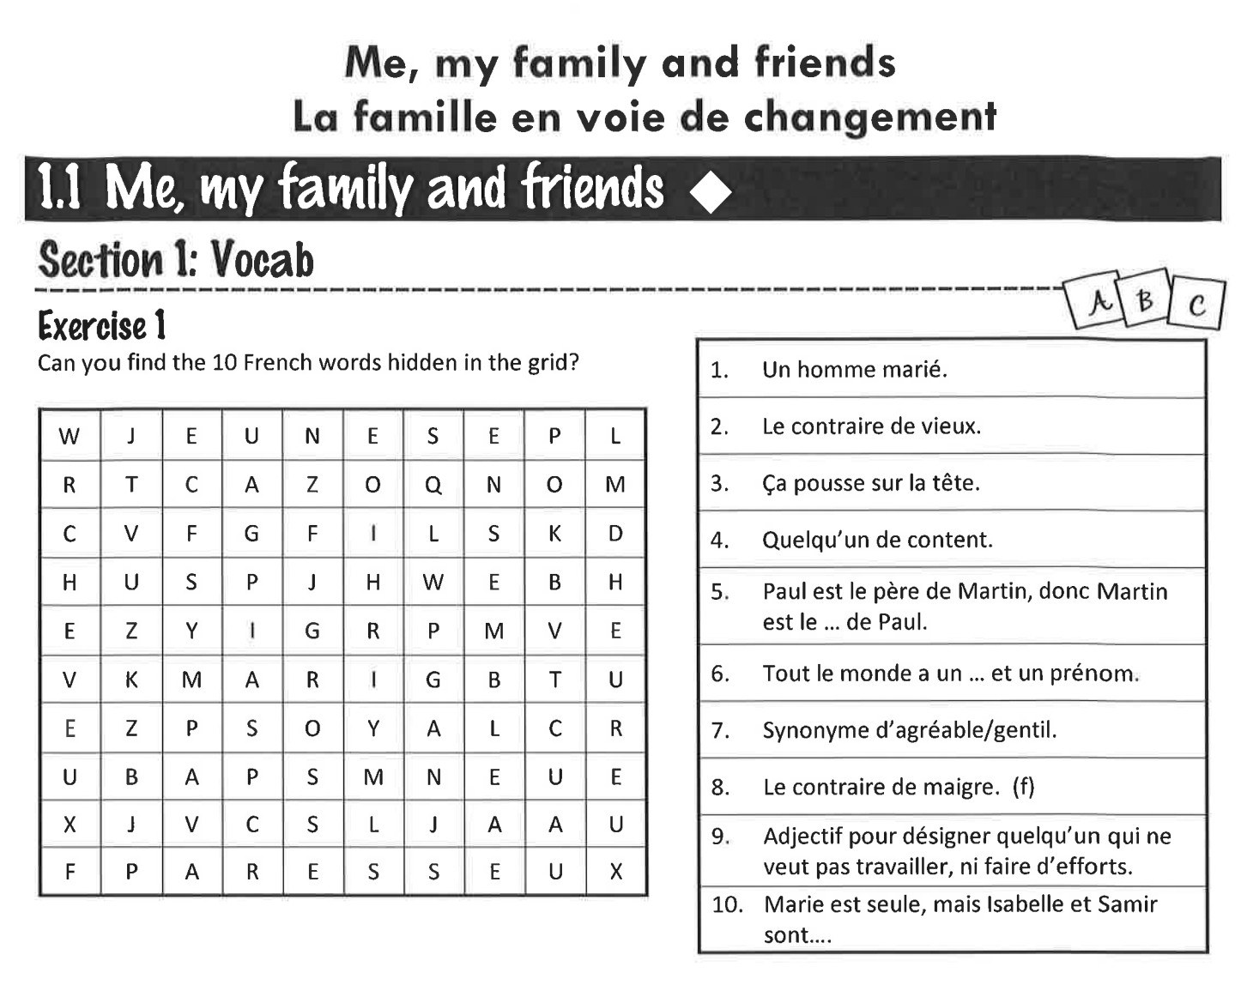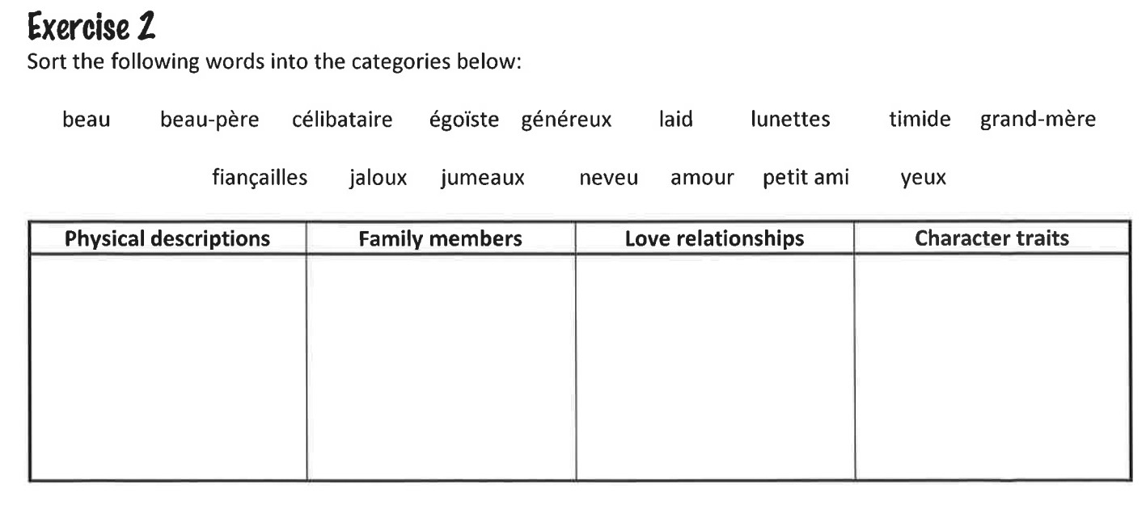
TASK 3

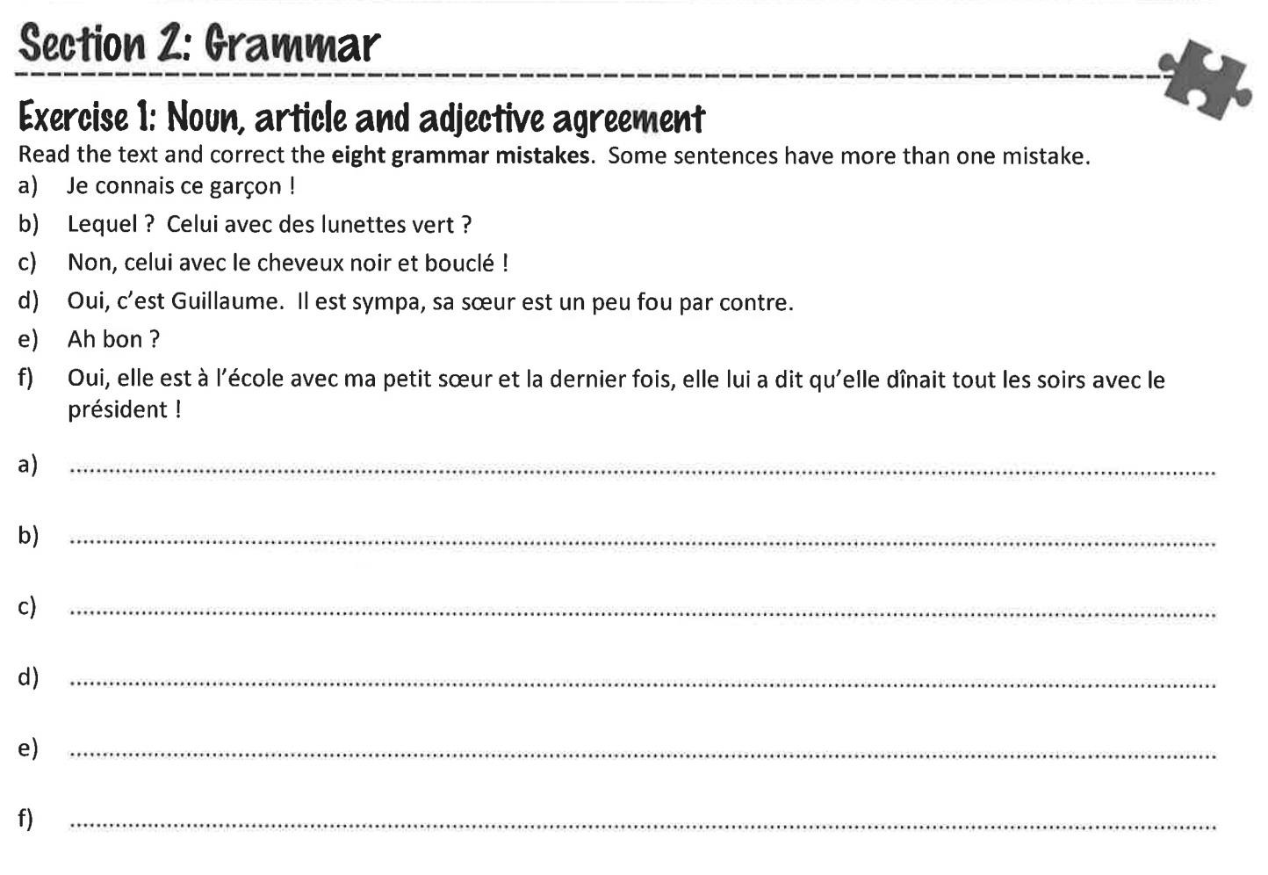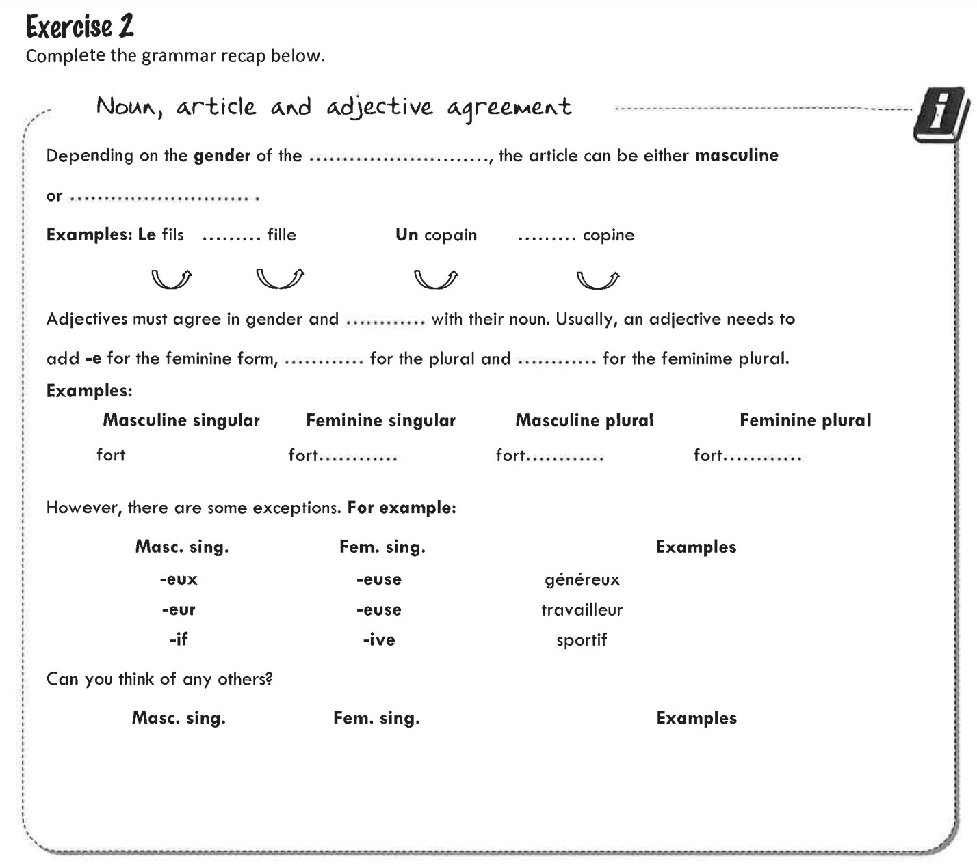

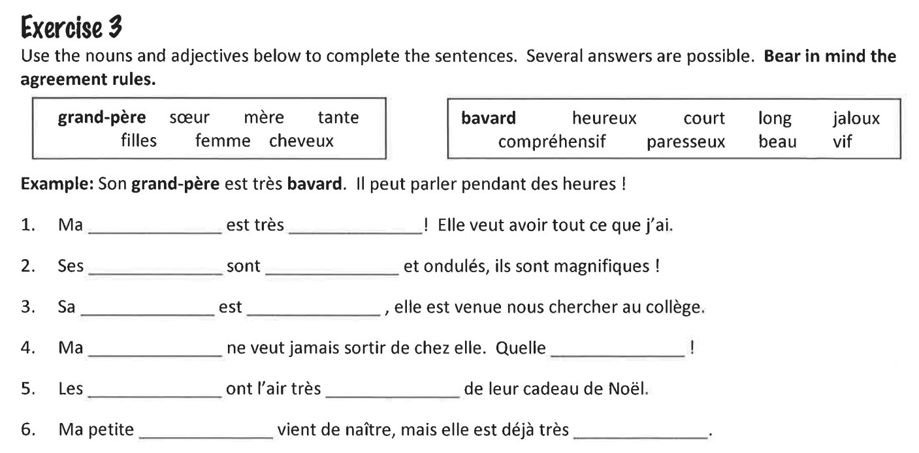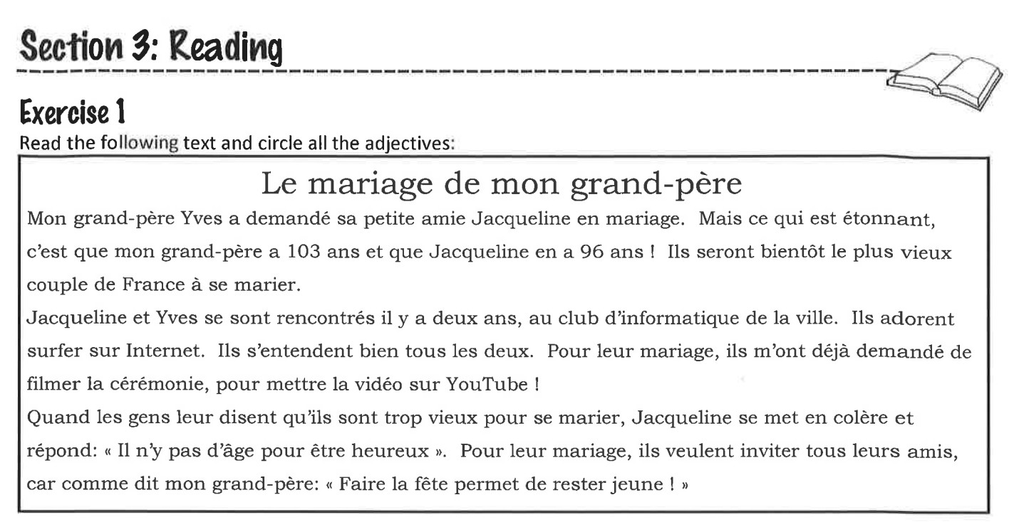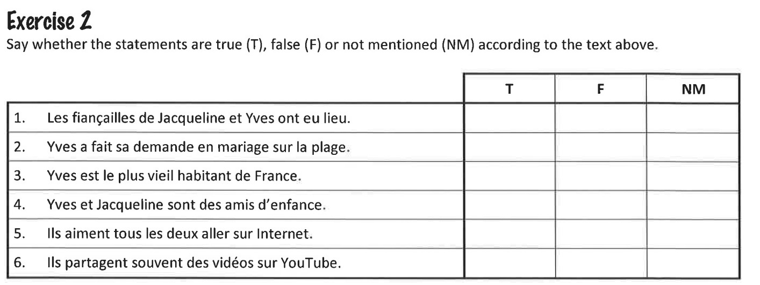

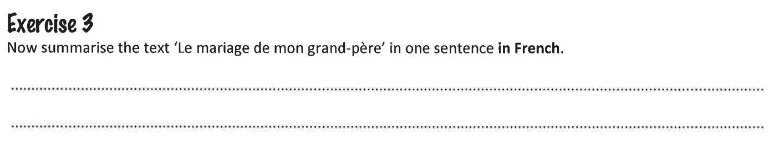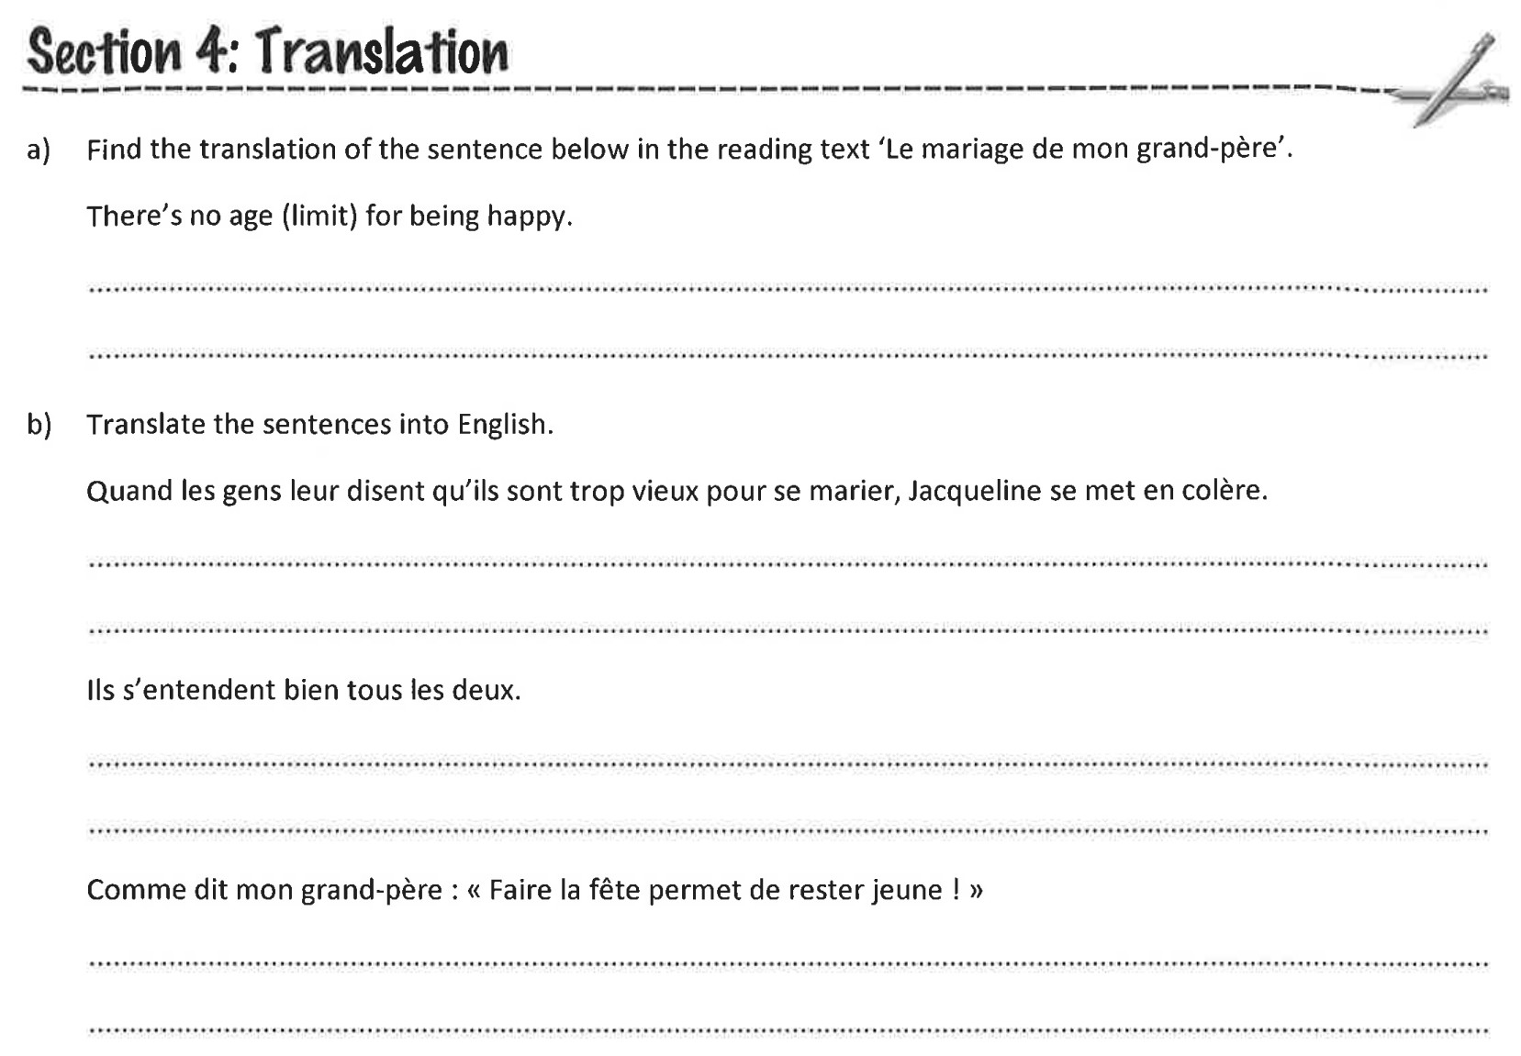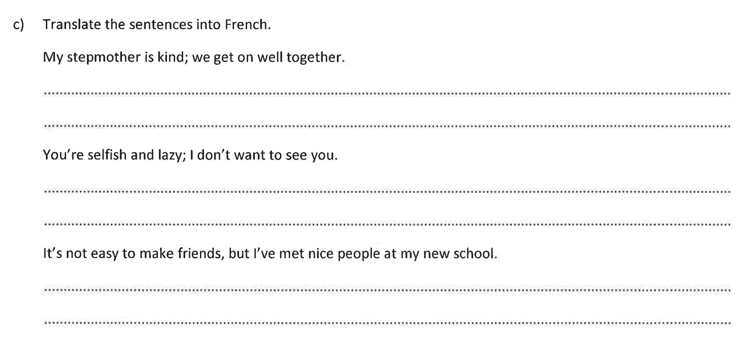

Section 5: Writing
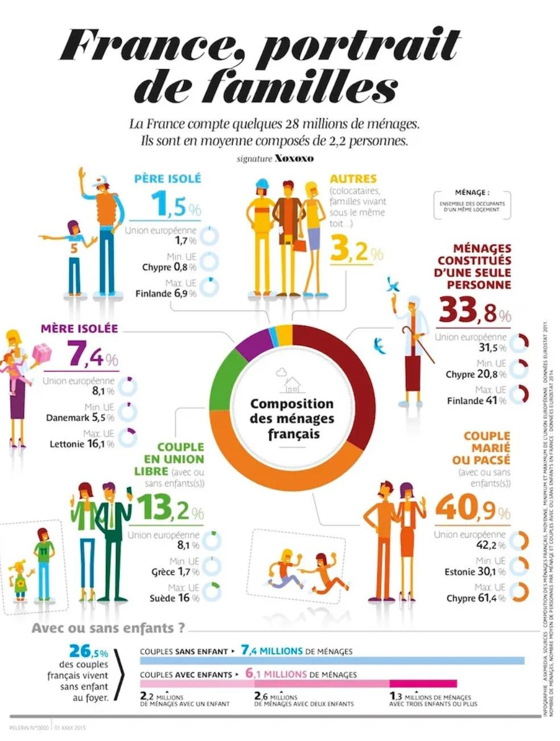

- Look at the infographic and make three observations in English: Ex: There are more single mothers than single fathers on average in the EU

- Now explain why you think these might be:
Ex: This could be because it is harder for mothers to leave their children for social reasons

- Use this vocabulary on comparatives and superlatives in French to make three comparisons on information found in the infographic above in French.
Ex: Le pourcentage du couple marié ou pacsé est d’environ 40%. Il est plus grand que le pourcentage de couple en union libre qui est d’environ 13%.

Comparatives :
  - plus… (que) → more... (than)
  - moins… (que) → less... (than)
  - aussi… (que) → as... (as)

Superlatives :
  - le/la/les plus...→ the most ...
  - le/la/les moins...→ the least ...
Learn more at : https://www.bbc.co.uk/bitesize/guides/zpr8b82/revision/1

- Now compare the percentages for France with the average in the E.U.. Are there similarities or striking differences? Write down three observations in English.

- Are you surprised at the figures regarding couples with and without children? Why? Why not? Explain in English.

Aspects of French-speaking society: current trends (in relation to any French-speaking country or countries
La famille en voie de changement - The changing nature of family
Grands-parents, parents et enfants (soucis et problèmes)
________________________________________________________Monoparentalité, homoparentalité, familles recomposées
________________________________________________________La vie de couple – nouvelles tendances
________________________________________________________

La « cyber-société » - The ‘cyber-society’
Qui sont les cybernautes?
________________________________________________________
Comment la technologie facilite la vie quotidienne.
________________________________________________________
Quels dangers la « cyber-société » pose-t-elle?
________________________________________________________

Le rôle du bénévolat - The place of voluntary work
Qui sont et que font les bénévoles?
________________________________________________________
Le bénévolat – quelle valeur pour ceux qui sont aidés?
________________________________________________________
Le bénévolat – quelle valeur pour ceux qui aident?
_______________________________________________________

- Draw a mind map of French nouns, verbs, adjectives and useful phrases connected with the themes in bold above.
- Start to think about and research some of these themes. Can you think of benefits/advantages or dangers/disadvantages connected with them? Make two lists in English, and possibly in French.
- Start to form your own opinions about them. How would you go about expressing these opinions in French? Compile a list of opinion phrases to express what you think, include positive and negative opinions.

TASK
2

Choose a French-spoken film, an episode of a TV series, an episode of the Youtube channel Visites Privées and answer the following questions:

  - Pourquoi as-tu choisi ce film/ cet épisode?
  - Qu’as-tu appris de nouveau sur la culture francophone?
  - Quels sujets sont traités dans le film / l’épisode de ton choix?
  - Qu’aimerais-tu apprendre de plus sur la culture francophone?
  - Quels sont les sujets qui t’intéressent le plus en général ?


TASK 3

Section 5: Writing

- Look at the infographic and make three observations in English: Ex: There are more single mothers than single fathers on average in the EU

- Now explain why you think these might be:
Ex: This could be because it is harder for mothers to leave their children for social reasons

- Use this vocabulary on comparatives and superlatives in French to make three comparisons on information found in the infographic above in French.
Ex: Le pourcentage du couple marié ou pacsé est d’environ 40%. Il est plus grand que le pourcentage de couple en union libre qui est d’environ 13%.

Comparatives :
  - plus… (que) → more... (than)
  - moins… (que) → less... (than)
  - aussi… (que) → as... (as)

Superlatives :
  - le/la/les plus...→ the most ...
  - le/la/les moins...→ the least ...
Learn more at : https://www.bbc.co.uk/bitesize/guides/zpr8b82/revision/1

- Now compare the percentages for France with the average in the E.U.. Are there similarities or striking differences? Write down three observations in English.

- Are you surprised at the figures regarding couples with and without children? Why? Why not? Explain in English.

