A Level Dance

Yr11 - Yr12
Transition Activities
Welcome to A Level Dance

Before you start the course in September we would like you to complete this booklet in as much detail as possible. Some of the tasks are research based and require reading and selecting information, others are more specific and require you to create timelines and smart targets. We would like you to bring all your completed work to your first A Level lesson in September. You will also be tested on what you have learnt in the first half term.

Name:

Which school did you attend to sit your GCSE’s/BTEC?

Did you do GCSE Dance?

Do you currently or have you studied Dance outside of school? (e.g. Ballet, Modern, Tap etc)

What are your strengths? (this could include dance specific information, e.g. a particular style or performing or it could be more general, e.g. essay writing or organisation)

What are your weaknesses?

What are you most looking forward to in the A Level Dance course?

Is there anything that you’re not looking forward to or worried about within the A Level Dance course?

Set yourself three targets to try and achieve between September and December (these targets should be Dance specific)

Target one:

Target two:

Target three:

The A Level Dance course at a glimpse
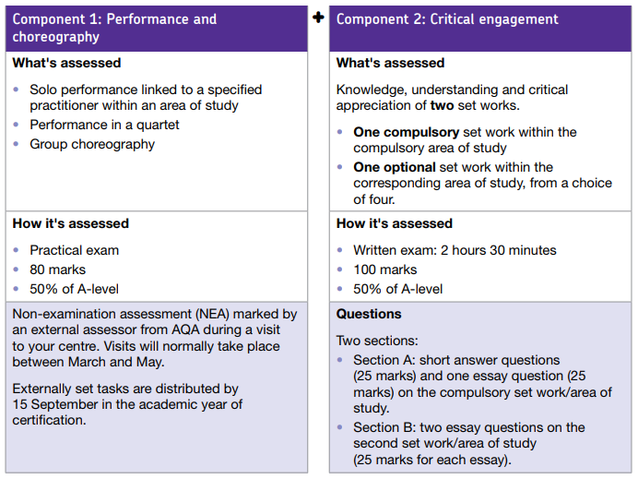
More information about the course can be found on the AQA website:
http://filestore.aqa.org.uk/resources/dance/specifications/AQA-7237-SP-2016.PDF

A Level Dance provides students with the opportunity to gain experience of performance and choreography and to develop critical thinking about Dance.
A Level Dance helps students to:
- Think critically about Dance as an art form
- Develop their knowledge for the study of Dance in higher education
- Experience performance and choreography through practice
- Lead a healthy lifestyle

The practical elements amount to 50% of the full qualification.

This course is particularly suitable for students who have studied GCSE/BTEC Dance and wish to study dance at a higher level.

The content allows students to study a subject which can be extended through higher education and promotes a healthy lifestyle through an awareness of the importance of exercise and training.
For one of the theoretical elements of the course you will be required to study the following areas…

Compulsory Set work: Rooster (1991) by Christopher Bruce
Compulsory Area of Study: Rambert Dance Company (formally Ballet Rambert) 1966-2002

You are expected to complete the following tasks and bring them back into your first lesson in September. You must complete all of the numbered tasks. The extension tasks are optional

Task 1: Create a biography of Christopher Bruce’s life and try to include the following information:
- A photograph
- Childhood
- Dance training
- Career
- Stylistic features
- Awards

Extension task: Can you find some of Christopher Bruce’s other dance works? Briefly describe the similarities and differences.

Task 2: Research Rooster (1991) by Christopher Bruce. Try and find information on the following:
- Stylistic features of the movement
- Physical setting
- Aural setting
- Costume

Extension task: What is the piece about?

Task 3: Create a timeline of the significant events in the history of Rambert Dance Company, start at 1966 and finish at 2002. What changed in the company?

Extension task: Try to think about what impact these events had on the company and add this to your timeline in a different colour.

