Pupil premium strategy statement – Northampton School for Girls

This statement details our school’s use of pupil premium funding to help improve the attainment of our disadvantaged pupils.
It outlines our pupil premium strategy, how we intend to spend the funding in this academic year and the outcomes for disadvantaged pupils last academic year.

School overview
Detail | Data
Number of pupils in school | 1376
Proportion (%) of pupil premium eligible pupils | 19.11%
Academic year/years that our current pupil premium strategy plan covers (3-year plans are recommended – you must still publish an updated statement each academic year) | 2023-26
Date this statement was published | November 2024
Date on which it will be reviewed | June 2025
Statement authorised by | Cristina Taboada-Naya
Pupil premium lead | Catherine Carré
Governor / Trustee lead | Dawn Lewis

Funding overview
Detail | Amount
Pupil premium funding allocation this academic year | £193200
Pupil premium funding carried forward from previous years (enter £0 if not applicable) | £0
Total budget for this academic year  If your school is an academy in a trust that pools this funding, state the amount available to your school this academic year | £193200

Part A: Pupil premium strategy plan

Statement of intent
NSG is committed to closing the attainment gap between disadvantaged students and their peers, our educational aims are the same for all. Evidence
demonstrates that great teaching and careful planning can make a huge impact on the outcomes of students in receipt of the Pupil Premium Grant. Improved
levels of achievement for pupil premium students will improve their chances for economic wellbeing through improved labour market outcomes, this will also
translate into better economic productivity for the country.

We are committed to:
● Making our broad and ambitious curriculum accessible to every student
● Ensuring all subject staff know their students well, use their subject expertise, along with quality teaching and learning provision to respond to the accurately diagnosed needs of students, whatever their prior attainment
● Implementing additional support and intervention where necessary to assist students in closing the gaps in their learning
● Working closely with parents and carers to keep them informed of their child’s progress

We know that due to the continuing economic impact of the pandemic, more children are likely to be facing challenges which indirectly impact on attainment, such as poverty or food insecurity, along with the stress of financial worries, and equitable access to technology.

The areas containing our catchment have worsened by 2 or 3 deciles since 2015. Three of the county’s boroughs and districts contain a greater proportion of deprived Lower Super Output Areas (LSOAs) (deciles 1 and 2) than the 20% national division with Northampton being 23.3%.

Index of Multiple Deprivation (IMD) 2019 Profile: Northampton

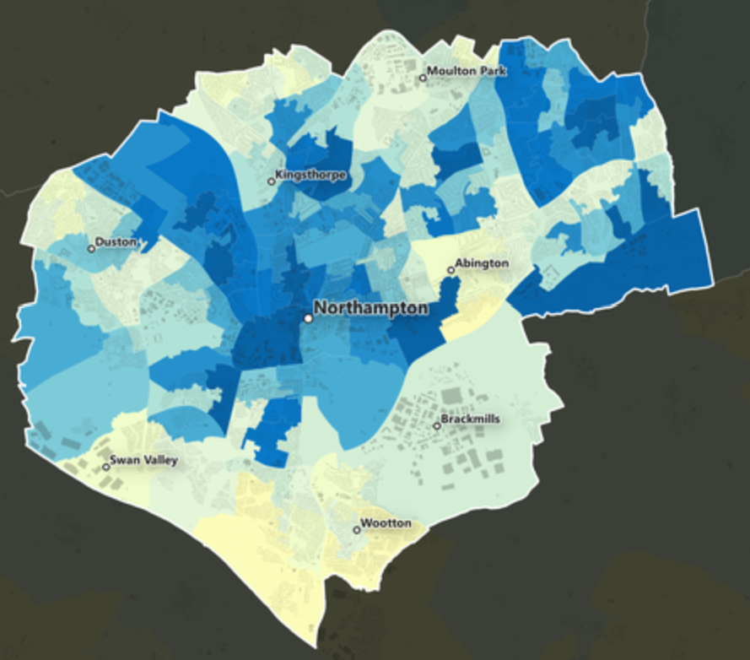

There are 422 LSOAs in Northamptonshire. Of these, 24 LSOAs are amongst the top 10% most deprived in England and 38 fall within decile 2 nationally. Thus, 62 (14.7%) of the LSOAs in Northamptonshire are amongst the top 20% most deprived nationally. The equivalent figures in 2015 were 29, 40, 69 and 16.4% respectively, although 20 LSOAs have moved within, into or out of this group. Exactly half of the 2019 deprived LSOAs are found in Northampton. Across England as a whole, the index will, of course, place 20% of LSOAs within deciles 1 and 2. 6 Three of the county’s boroughs and districts contain a greater proportion of deprived LSOAs (deciles 1 and 2) than the 20% national division. These are Corby (29.3%), Northampton (23.3%) and Wellingborough (21.3%). South Northamptonshire has no deprived LSOA in the top 20% of deprived counties. In 2023, 23.8% of pupils were eligible for free school meals, up from 22.5% in 2022. In 2024 this has risen further to 24.6%. This represents over 2 million pupils.

In the East Midlands in 2024, 24.1% of pupils were eligible for free school meals compared to 21.5% of all pupils in 2022. Whilst the percentage is lower than national average, we as a school have a truly representative Northamptonshire cohort. In 2024 our new Year 7 were distributed from 80 different primary schools.

The West Northamptonshire (WN) Anti-Poverty Strategy for 2022- 2025 states that child poverty continues to increase since the data gathered in 2019 when 13.9% (10,231) of children were living in poverty in WN. We also know that these measures of child poverty do not present a true picture of the number of children living in deprivation. Citizen’s Advice have found that only 30% of people accessing their services live in the most deprived areas.

Northampton School for Girls is located in a “leafy suburb” with the Office for National Statistics recording average house prices close to the school as being 1.7 % higher than the rest of West Northamptonshire. To ensure that all communities across Northamptonshire, including the most deprived, have equal access to NSG we operate fair banding, rather than a catchment area approach to admissions.

Challenges
This details the key challenges to achievement that we have identified among our disadvantaged pupils.
Challenge number | Detail of challenge
1 | Making our broad and ambitious curriculum accessible to every student with High Quality Teaching so that the progress and attainment gap closes.
2 | Eliminating reading poverty & recovering pupil premium students’ Reading Age (RA) in line with Chronological Age (CA)
3 | We recognise that PP students are more likely to fall behind their peers both in attainment and wellbeing at key transition points. Mitigating the pandemic impact on our pupil premium students has been, and will continue to be, a major focus. We fully understand that the impact of the pandemic has not been felt equally across all our students and that key transition years, or those at different stages in their primary education at the time, will be more heavily impacted.
4 | Improving communication and partnership between parents/carers to engage them in learning to support improved attendance and better home learning.
5 | Students are unlikely to make the expected levels of progress required or realise their full potential unless they attend school regularly. Attendance of all PP students in Year 7 to 13 meets the school target of 97%. The number of PP students who are persistently absent are reduced by 15%.

Intended outcomes
This explains the outcomes we are aiming for by the end of our current strategy plan, and how we will measure whether they have been achieved.
Intended outcome | Success criteria
Progress 8 | There is no gap between the progress score of PP students and non PP. ALL students achieve a positive P8 score. August 2025
Attainment 8 | 90% of PP students achieve their expected target grade and 50% of PP students achieve their aspirational target grade. PP students achieve above local / national average for attainment for all students. August 2025
Percentage of Grade 5+ in English and maths | Achieve in the top 5% of schools nationally for the percentage of Grade 5+ in English and Maths August 2025
Reading Age @ Chronological Grade | Reading age returns to the pre-pandemic level of 65% at chronological age by the end of Key Stage 3. June 2025
Ebacc entry PP & Non PP = 90% | Yr 9 choices April 2025
Attendance | Attendance of all PP students in Yr 7 to 13 meets the school target of 97%. The number of PP students who are Persistently Absent is reduced so that it is significantly below the national average. August 2025

Activity in this academic year
This details how we intend to spend our pupil premium funding this academic year to address the challenges listed above.

Teaching (for example, CPD, recruitment and retention)
Budgeted cost: £ 103200
Activity | Evidence that supports this approach | Challenge number(s) addressed
Identify how the curriculum needs for pupil premium students can be met so that they know more, can remember more and do more | The Education Endowment Fund has identified that good teaching is the most important lever schools have to improve outcomes for disadvantaged pupils. Using the Pupil Premium to improve teaching quality benefits all students and has a particularly positive effect on children eligible for the Pupil Premium. Pupil premium students must not, however, be seen as a homogenous group (Allen, 2018). The learning needs of each pupil premium student must be accurately diagnosed so that teachers can respond with expertise in the way they implement the curriculum.  Through continued review of the curriculum, evidence informed continued professional development, instructional coaching to facilitate regular dialogue about “great teaching” (Coe et al, 2020), and close monitoring and evaluation of the quality of education, progress and attainment will improve. | 1
Implement a quality assured, evidence based CPD programme to support quality first teaching to address the identified learning needs of pupil premium students. This will form an integral part to the school's formative process for performance management. | All teachers will receive instructional coaching and feedback on evidence-informed teaching strategies selected as having the best chance of responding to the diagnosed needs of the Pupil Premium students they teach. This will follow the ADAPT model (Sherrington, 2020)  Walkthrus 5 step guide to instructional coaching Sherrington, T. Great Teaching Toolkit Coe etal DfE Pupil Premium Overview DfE Pupil Premium Guidance for School Leaders EEF Guide to the  EEF Effective Professional Development EEF Effective Professional Development summary poster | 1
Introduce a tiered approach to intervention for improving reading based on students current reading ages using data from both NGRT and Accelerated Reader | We know that that in July 2022 KS2 attainment in all of reading, writing and maths decreased compared to 2019: At KS2 in July 2022 and 2023 59% of pupils met the expected standard in all of reading, writing and maths. This is down from 65% in 2019. We know that success in a subject is grounded in a child's ability to read and comprehend and apply new knowledge. We know that literacy is not the sole remit of the English teachers and that adopting disciplinary literacy will support teachers in all subjects with strategies to help students read, write, and communicate effectively (EEF KS3&4 literacy guidance). We know that where intervention is specifically targeted it is more effective. | 2
Our Reading and Intervention Lead and Numeracy and Intervention Lead oversee and quality assure whole school literacy intervention to support lost learning for disadvantaged students and reduce attainment gaps. Develop whole school numeracy intervention to support lost learning for disadvantaged students and reduce attainment gaps. | Pupil Premium Guide 1 Education Endowment Foundation 1 EEF  Andrew Quigley - Reducing the Reading Gap Disciplinary literacy | National Literacy Trust  EEF Blog: What do we mean by 'disciplinary literacy'? Improving Literacy in Secondary Schools | EEF EEF's Pupil Premium guide. EEF - Improving Mathematics in Kev  Stages Two and Three - Recommendations Summary | 2
Implement a quality assured and effective strategy to ensure all PP students that are more vulnerable (PP/SEND/Girls) are actively monitored across transition points and their progress is tracked. Interventions will be put in place for those that are highlighted and this will form part of targeted academic support. | Pupil Premium Guide 1 Education Endowment Foundation 1 EEF  Pupil Premium and SEND: learning without labels  We know that if you are both a girl, PP and SEND you are less likely to perform as well as your peers. Key Transitions throughout secondary school need to be monitored and students need to have access to bespoke support if needed. | 3

Targeted academic support (for example, tutoring, one-to-one support, structured interventions)
Budgeted cost: £ 68193.31
Activity | Evidence that supports this approach | Challenge number(s) addressed
Structured inventions for PP/SEND/Girls who require support either pastorally or academically. These students will be tracked and monitored across key transition points. | Pupil Premium Guide 1 Education Endowment Foundation 1 EEF  We know that if you are both a girl, PP and SEND you are less likely to perform as well as your peers. Key Transitions throughout secondary school need to be monitored and students need to have access to bespoke support if needed. | 3
Ensure Access to Technology to facilitate all online and blended learning for PP and more vulnerable students. | National Tutoring Programme Guidance for Schools 2022 to 2023 Research into the Evaluation of the National Tuition Programme: Tuition Partners | 4
Implement a formal timetable for communication with parents centred around consultation evenings, data drops, transition periods and online events.  Recruit non-teaching pastoral support officers (PSO) to facilitate timely communication with parents as it is needed | Utilise flexible virtual communications opportunities to avoid barriers of transport and availability. Provide technology to students to support parental contact as internal data shows that these parents are less likely to attend parents evenings. | 4

Wider strategies (for example, related to attendance, behaviour, wellbeing)
Budgeted cost: £ 21,806.69
Activity | Evidence that supports this approach | Challenge number(s) addressed
Pastoral/ Inclusion team dedicated to focusing on attendance and student welfare. | DfE Pupil Premium Overview DfE Pupil Premium Guidance for School Leaders | 5
Provide dedicated curriculum learning environments for vulnerable students | EEF Special Educational Needs in Mainstream Schools Guidance Report | 1,5
Offer in-house counselling to ensure students receive support as soon as possible to reduce impact on their learning | Cooper, M., Stafford, M.R., Saxon, D., et al. (2021). Humanistic counselling plus pastoral care as usual versus pastoral care as usual for the treatment of psychological distress in adolescents in UK state schools (ETHOS): a randomised controlled trial. The Lancet Child & Adolescent Health, [online] 5(3), pp.178–189. doi:https://doi.org/10.1016/s2352-4642(20)30363-1. | 3,5
Engaging parents/carers in supporting 100% attendance for their child | Pupil absence in schools in England: autumn term 2019  Attendance: persistent absence threshold and statistics  Reducing persistent absence - Attendance Matters Magazine  Harris, A and Goodall, J (2008) Do parents know they matter? Engaging all parents in learning. Educational Research, 50 (3): 277-289 | 5
Delivering our bespoke Year 7 - First 100 days induction  Programme to fully ensure that students transition well into secondary school. | Year 7 is a key transition point for students to feel a sense of belonging in a new secondary school. It is particularly important for those who are SEND/PP and those with SEMH.  School Transition and Adjustment Research Study (STARS) | 3,4,5
Delivering our Year 9 - Choices programme so that all students will be supported and encouraged to access EBacc subjects. | Research evidence supports the importance of credentials in these EBacc subjects for future access to professional routes and careers, yet failure magnifies disadvantage for these pupils, and these factors must be carefully balanced in exam entry. | 1,3
Transition to Post 16 - To deliver our Year 11, Post 16 and further develop Careers PSHE programmes to support the transition process to Post 16 | Disadvantaged students are less likely to take up Post-16 STEM subjects where women are underrepresented.  Social background is strongly predictive of attainment at KS4 and therefore post-16 pathway options. | 1, 3
Proactively promote development of cultural capital and enrichment through ensuring equitable participation in extracurricular opportunities | Attending extra curricular clubs has a large range of positive outcomes for disadvantaged students. | 1,3,5

Total budgeted cost: £ 193,200

Part B: Review of the previous academic year

Outcomes for disadvantaged pupils
Aim | Target | Target Date | Reflection
Progress 8 | There is no gap in progress. All to have a positive P8. | August 2024 | Our pupil premium (PP) students have achieved a positive Progress 8 score of 0.08 in 2024, a significant improvement from the 2023 score of -0.32. This upward trend demonstrates the effectiveness of our strategies to support PP students and highlights their hard work and commitment. Meanwhile, our non-pupil premium students achieved a Progress 8 score of 0.49, reflecting good overall progress. While the gap between PP and non-PP students has narrowed, we remain steadfast in our commitment to eliminating this disparity. Our goal is to ensure that by 2025, there is no gap in attainment between PP and non-PP students, providing equitable opportunities for all learners to excel.
Attainment 8 | 90% of PP students achieve their expected target grades. 50% PP students achieve their aspirational target grade. PP students achieve above local/national average. | August 2024 | In 2023, our Attainment 8 score for pupil premium (PP) students was 39.6, a result that reflected a challenging year and did not align with our historically stronger performance. Encouragingly, in 2024, we have made significant progress by increasing the score to 41.8. Despite this improvement, the Attainment 8 for PP students remains below that of our non-pupil premium peers, who achieved a score of 53.4. This academic year, we are committed to minimizing this gap and ensuring that our PP students achieve the same high standards as their non-PP counterparts. Through targeted support and dedicated efforts, we aim to create an equitable learning environment where all students can excel equally.
Percentage of Grade 5+ in English and Maths | Achieve in the top 5% of schools nationally for 5+ in English and Maths. | August 2024 | 54.3% Non-PP students achieved a grade 5 in both English and Maths. Whereas only 23.8% of PP students achieved this. This is a challenge that we are addressing this year to enable our PP students to achieve in both English and Maths and our targeted curriculum support is continuing to address this.
Reading Age at Chronological Age | Reading age returns to the pre-pandemic level of 65% at chronological age by the end of Key Stage 3. | June 2024 | We have made encouraging progress toward our target of ensuring all KS3 pupil premium (PP) students achieve a reading ability at their chronological age. In Year 7, 64.9% of students are currently reading at their chronological age, with 50.9% reaching a reading age of 12.6. Year 8 has shown steady improvement, increasing from 66.6% at chronological age in September 2023 to 69.4% in September 2024, while those at 12.6 rose more significantly from 66.6% to 71.4%. Year 9 presents a mixed picture, with the percentage of students reading at chronological age decreasing from 66.6% in September 2023 to 60.9% in September 2024; however, there has been notable progress in those reading at 12.6, rising from 66.6% to 73.9%. These results reflect ongoing efforts to enhance literacy skills across KS3, and we remain focused on addressing any areas of decline while building on our successes.
Ebacc Entry | PP & Non PP = 90% | Y9 Choices April 2024 | April 2024: The following data shows students who completed KS4 in 2023  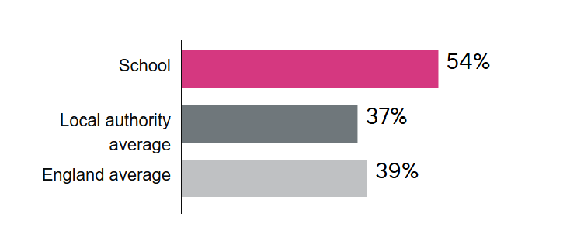  Our EBacc entry numbers remain a strong area of success, with 54% of our students entering the English Baccalaureate in 2023—well above the national average and significantly higher than the local figure of 37%.  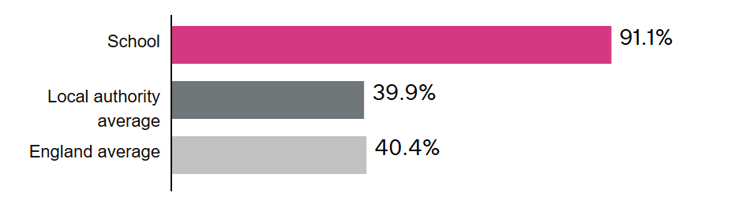  In 2024, this has increased dramatically. This upward trend reflects our dedication to providing a broad and balanced curriculum that equips students with essential academic qualifications. As we continue to build on this progress, we remain firmly committed to achieving our ambitious target of 90% EBacc entry for both pupil premium and non-pupil premium students by the end of our three-year plan, ensuring equity and opportunity for all.
Attendance | Attendance of all PP students in Yr 7 to 13 meets the school target of 97%. The number of PP students who are Persistently Absent is reduced so that it is significantly below the national average. | August 2024 | 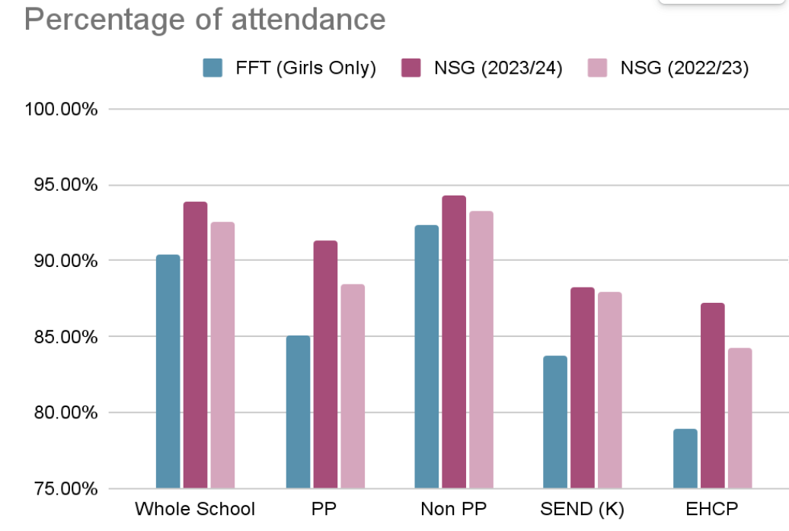  This table, from August 2024, shows that our students who are PP have a significantly higher attendance than the girls national average. When comparing to ourselves from 22/23 we have also had a positive improvement in attendance across all groups.  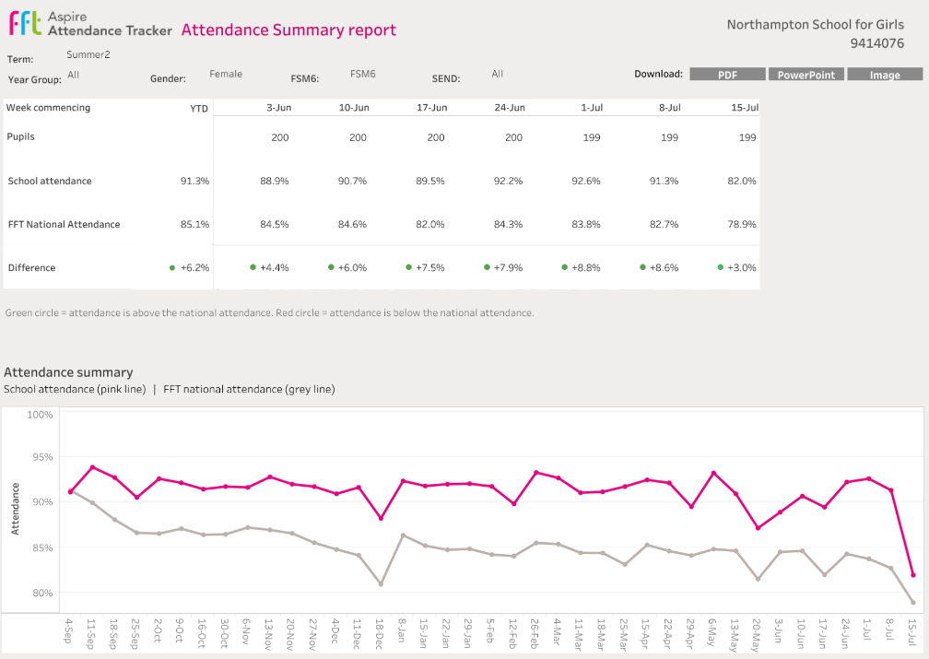  When analysing PP attendance across the year, the pattern is consistent with national although we maintain higher than national average across the year. The work that we do to ensure attendance for our PP girls is of the upmost importance and is reflected in this data. Attendance peaks and troughs are consistent with seasonal patterns, such as lower attendance during winter months or just before breaks. There is a significant dip in attendance the week before each holiday, and although consistent with national, we aim to investigate this further and have as a focus for next year’s attendance monitoring and intervention.  Whilst we are proud of our efforts to improve year on year, students who are PP do not yet attend school as much as their peers, and we remain committed to eliminating this gap.

Summary
The results for our pupil premium students this year have shown significant progress, marking a positive shift compared to the previous year. This improvement highlights the impact of our targeted interventions and the collective efforts of staff and students in fostering an inclusive and supportive learning environment. We are pleased to see the gap between pupil premium and non-pupil premium students narrowing, reflecting our commitment to equity and excellence. With continued dedication and providing students with opportunities to thrive, we are on track towards minimising this gap further and ultimately eradicating it, ensuring all students achieve their full potential regardless of their background.
6 Year Trend in PP Outcomes
Progress 8 PP | 2019= -0.12 ( Gap= 0.6) | 2020 = 0.13 (Gap= 0.31) CAG | 2021 = 1.18 (Gap =0.07)  TAG | 2022=0.2 (Gap= 0.48) Adjusted | 2023=-0.34 (Gap= 1.01) | 2024 =0.08  (Gap= 0.41)
Ebacc entry PP (Non PP) | 2019 = 41% (50%) | 2020 36.1 (50.5%) | 2021 44.4% (51.6%) | 2022 30% (62.1%) | 2023 43% (54%) | 2024 = 85.7%  (91.1%)
Attainment 8 PP | 2019 =43 (Gap= 9) | 2020 =46 ( Gap= 11 )  CAG | 2021=56(Gap= 6)  TAG | 2022=45.9 (Gap= 12.87) Adjusted | 2023=39.3 (Gap= 17.1) | 2024 = 41.8  (Gap = 11.6)
Percentage of Grade 5+ in English and Maths | 2019 = 33% (Gsp=18%) | 2020= 39% (Gap=16%) CAG | 2021= 53.7% (Gap= 14%) TAG | 2022 =37% (Gap= 26.3%)  Adjusted | 2023 =23% (Gap= 38%) | 2024 = 23.8%  (Gap = 30.5%)
Ebacc 5+ | 2019 = 20% ( Gap = 11%) | 2020= 13% (Gap = 12% ) CAG | 2021=25.9% (Gap = 9% )  TAG | 2022 =24.5 (Gap =24.4%) Adjusted | 2023 =11% (Gap =24.4%) | 2024 = 14.3%  (Gap = 25.7%)

Attendance of PP Diagrams 23-24
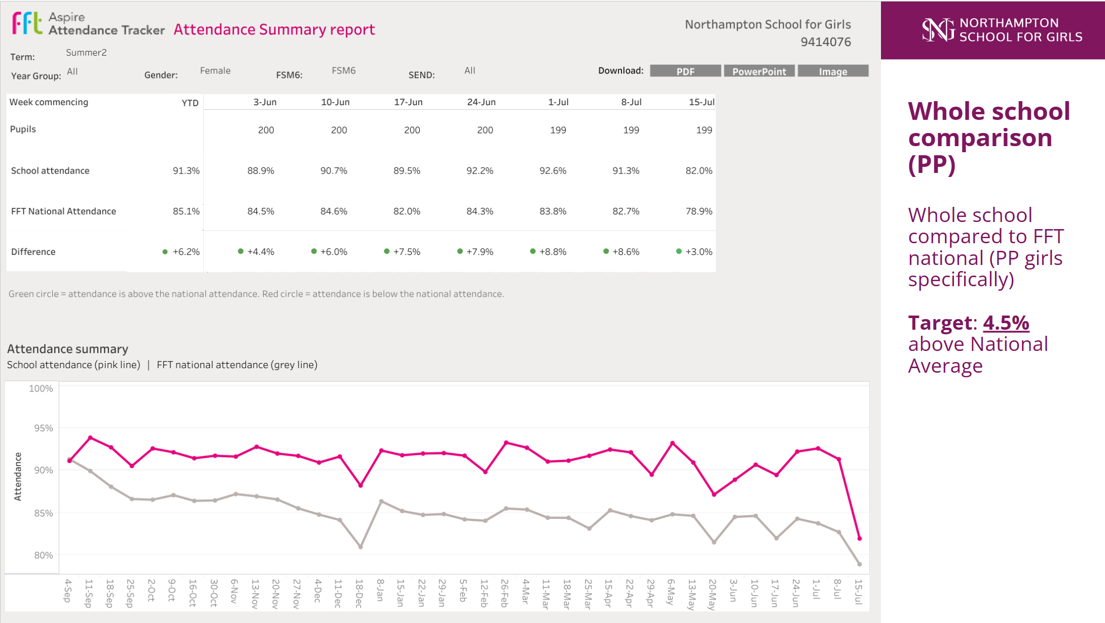
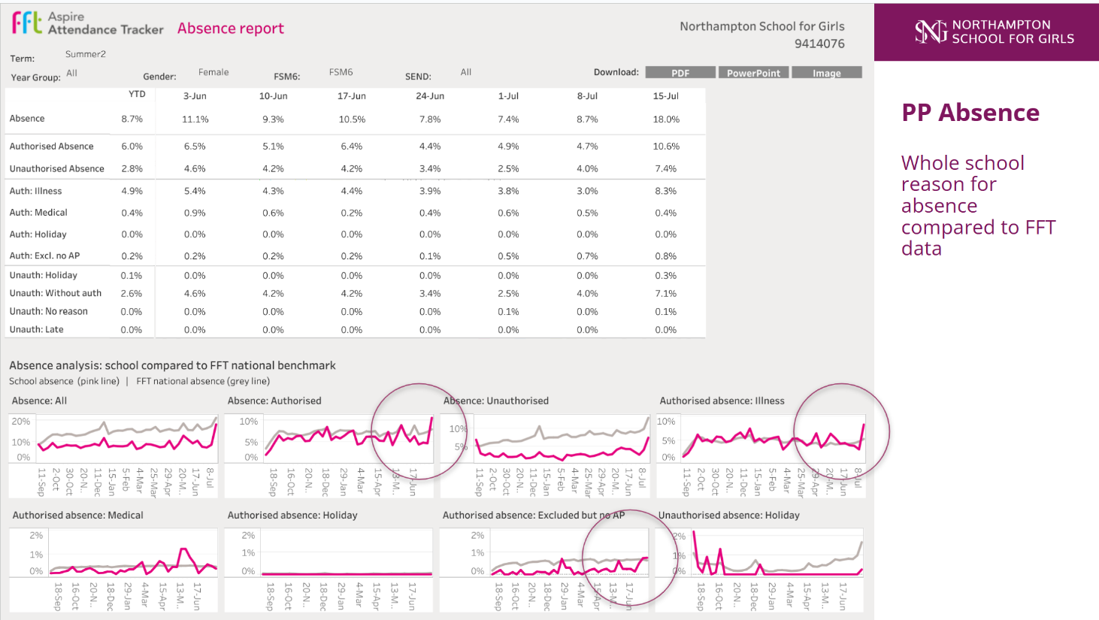
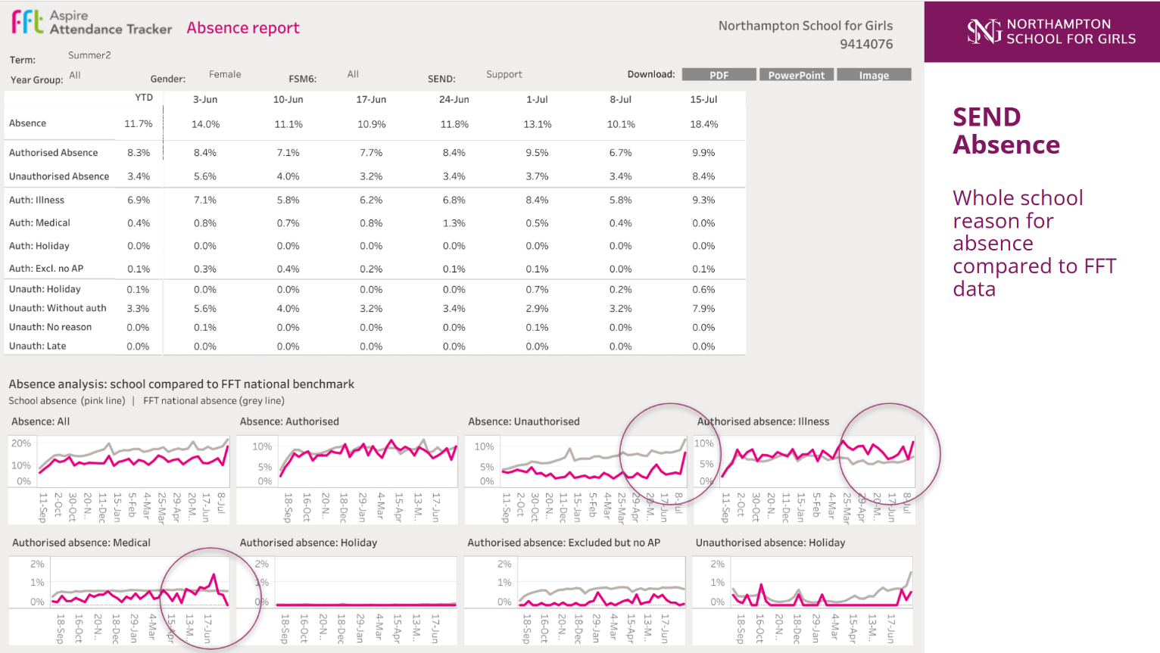

PP Spending Report 23-24
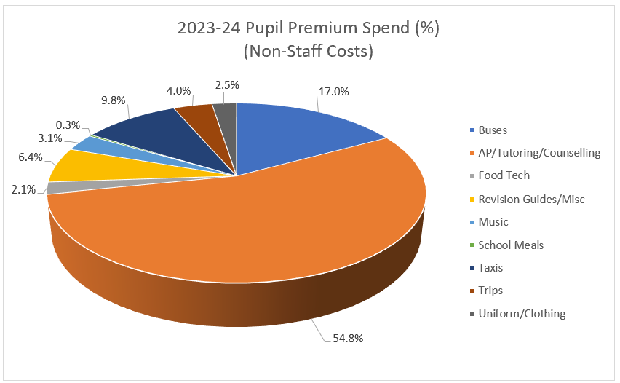
Pupil Premium Support and Impact Summary
As planned, the majority of our Pupil Premium (PP) funding was directed towards Tier 2: Targeted Support, ensuring that students who need the most help receive bespoke academic and pastoral interventions.
A significant proportion of the support provided focused on alternative provision, tutoring, and counselling, enabling students to access tailored academic and emotional support to help them engage successfully with learning. Additional funding was used to ensure that students could access school and extracurricular opportunities, including support with transport to and from school and wider enrichment activities.
Across the year, around 70% of PP and PP+ students benefitted directly from this funding. The analysis of our spending shows that resources were effectively targeted to those with the greatest need. A smaller proportion of students required intensive and sustained intervention such as bespoke alternative provision placements, therapeutic support, and individual tutoring to help remove barriers to learning and promote engagement.
This reflects our strategic approach, ensuring that funding is used where it will have the greatest impact while maintaining flexibility to respond to individual circumstances.
Among our PP+ students (those in care or previously in care), support was particularly focused on counselling, tutoring, transport, and enrichment opportunities, with fully funded access to music tuition and other targeted experiences designed to build confidence and aspiration.
In summary, our Pupil Premium funding has been used purposefully to provide a combination of academic intervention, emotional wellbeing support, and practical assistance, all aimed at ensuring our disadvantaged students are able to access the full curriculum and thrive in all aspects of school life.

Externally provided programmes
Please include the names of any non-DfE programmes that you used your pupil premium to fund in the previous academic year.
Programme | Provider
School led tutoring | National Tuition Programme
Accelerated Reader - with Star Tests | Renaissance Reading

Service pupil premium funding (optional)
For schools that receive this funding, you may wish to provide the following information: How our service pupil premium allocation was spent last academic year
The impact of that spending on service pupil premium eligible pupils

Further information

