Pupil premium strategy statement – Northampton School for Girls

This statement details our school’s use of pupil premium funding to help improve the attainment of our disadvantaged pupils.
It outlines our pupil premium strategy, how we intend to spend the funding in this academic year and the outcomes for disadvantaged pupils last academic year.

School overview
Detail | Data
Number of pupils in school | 1379
Proportion (%) of pupil premium eligible pupils | 15%
Academic year/years that our current pupil premium strategy plan covers (3-year plans are recommended – you must still publish an updated statement each academic year) | 2023-26
Date this statement was published | November 2025
Date on which it will be reviewed | June 2026
Statement authorised by | Cristina Taboada-Naya
Pupil premium lead | Catherine Carré
Governor / Trustee lead | Dawn Lewis

Funding overview
Detail | Amount
Pupil premium funding allocation this academic year | £222,525
Pupil premium funding carried forward from previous years (enter £0 if not applicable) | £0
Total budget for this academic year  If your school is an academy in a trust that pools this funding, state the amount available to your school this academic year | £222,525

Part A: Pupil premium strategy plan

Statement of intent
NSG is committed to closing the attainment gap between disadvantaged students and their peers, our educational aims are the same for all. Evidence
demonstrates that great teaching and careful planning can make a huge impact on the outcomes of students in receipt of the Pupil Premium Grant. Improved
levels of achievement for pupil premium students will improve their chances for economic wellbeing through improved labour market outcomes, this will also
translate into better economic productivity for the country.

We are committed to:
● Making our broad and ambitious curriculum accessible to every student
● Ensuring all subject staff know their students well, use their subject expertise, along with quality teaching and learning provision to respond to the accurately diagnosed needs of students, whatever their prior attainment
● Implementing additional support and intervention where necessary to assist students in closing the gaps in their learning
● Working closely with parents and carers to keep them informed of their child’s progress

We know that due to the continuing economic impact of the pandemic, more children are likely to be facing challenges which indirectly impact on attainment, such as poverty or food insecurity, along with the stress of financial worries, and equitable access to technology.

The areas containing our catchment have worsened by 2 or 3 deciles since 2015. Three of the county’s boroughs and districts contain a greater proportion of deprived Lower Super Output Areas (LSOAs) (deciles 1 and 2) than the 20% national division with Northampton being 23.3%.
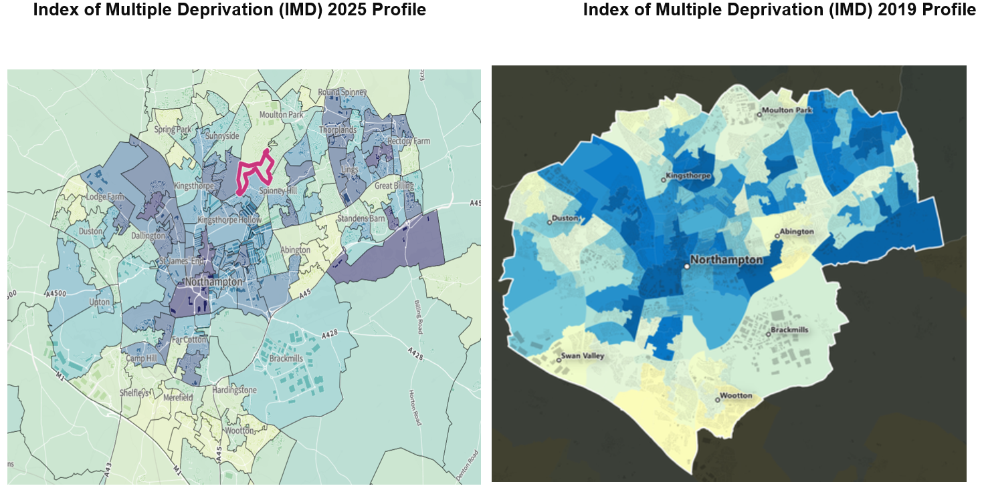
Although the full details of changes in deprivation levels across Northampton between 2019 and 2025 are not yet available, initial reports indicate that Northampton continues to have the highest proportion of its population (28.2%) living in the top 20% most deprived areas within the West Northamptonshire region. The forthcoming English Indices of Deprivation 2025 (IMD 2025) will offer a more comprehensive assessment; however, existing 2019 data and subsequent strategic reports continue to highlight the area’s significant and persistent deprivation challenges. Early evidence suggests that deprivation remains a pressing issue locally, and the forthcoming IMD 2025 data will be critical in understanding the extent of progress and emerging needs across the region.

There are 422 LSOAs in Northamptonshire. Of these, 24 LSOAs are amongst the top 10% most deprived in England and 38 fall within decile 2 nationally. Thus, 62 (14.7%) of the LSOAs in Northamptonshire are amongst the top 20% most deprived nationally. The equivalent figures in 2015 were 29, 40, 69 and 16.4% respectively, although 20 LSOAs have moved within, into or out of this group. Exactly half of the 2019 deprived LSOAs are found in Northampton. Across England as a whole, the index will, of course, place 20% of LSOAs within deciles 1 and 2. 6 Three of the county’s boroughs and districts contain a greater proportion of deprived LSOAs (deciles 1 and 2) than the 20% national division. These are Corby (29.3%), Northampton (23.3%) and Wellingborough (21.3%). South Northamptonshire has no deprived LSOA in the top 20% of deprived counties. In 2023, 23.8% of pupils were eligible for free school meals, up from 22.5% in 2022. In 2024 this has risen further to 24.6%. This represents over 2 million pupils.

In the East Midlands in 2024, 24.1% of pupils were eligible for free school meals compared to 21.5% of all pupils in 2022. Whilst the percentage is lower than national average, we as a school have a truly representative Northamptonshire cohort. In 2024 our new Year 7 were distributed from 80 different primary schools.

The West Northamptonshire (WN) Anti-Poverty Strategy for 2022- 2025 states that child poverty continues to increase since the data gathered in 2019 when 13.9% (10,231) of children were living in poverty in WN. We also know that these measures of child poverty do not present a true picture of the number of children living in deprivation. Citizen’s Advice have found that only 30% of people accessing their services live in the most deprived areas.

Northampton School for Girls is located in a “leafy suburb” with the Office for National Statistics recording average house prices close to the school as being 1.7 % higher than the rest of West Northamptonshire. To ensure that all communities across Northamptonshire, including the most deprived, have equal access to NSG we operate fair banding, rather than a catchment area approach to admissions.

Challenges
This details the key challenges to achievement that we have identified among our disadvantaged pupils.
Challenge number | Detail of challenge
1 | Making our broad and ambitious curriculum accessible to every student with High Quality Teaching so that the progress and attainment gap closes.
2 | Eliminating reading poverty & recovering pupil premium students’ Reading Age (RA) in line with Chronological Age (CA)
3 | We recognise that PP students are more likely to fall behind their peers both in attainment and wellbeing at key transition points. Mitigating the pandemic impact on our pupil premium students has been, and will continue to be, a major focus. We fully understand that the impact of the pandemic has not been felt equally across all our students and that key transition years, or those at different stages in their primary education at the time, will be more heavily impacted.
4 | Improving communication and partnership between parents/carers to engage them in learning to support improved attendance and better home learning.
5 | Students are unlikely to make the expected levels of progress required or realise their full potential unless they attend school regularly. Attendance of all PP students in Year 7 to 13 meets the school target of 97%. The number of PP students who are persistently absent are reduced by 15%.

Intended outcomes
This explains the outcomes we are aiming for by the end of our current strategy plan, and how we will measure whether they have been achieved.
Intended outcome | Success criteria
Progress 8 | There is no gap between the progress score of PP students and non PP. ALL students achieve a positive P8 score. August 2025
Attainment 8 | 90% of PP students achieve their expected target grade and 50% of PP students achieve their aspirational target grade. PP students achieve above local / national average for attainment for all students. August 2025
Percentage of Grade 5+ in English and maths | Achieve in the top 5% of schools nationally for the percentage of Grade 5+ in English and Maths August 2025
Reading Age @ Chronological Grade | Reading age returns to the pre-pandemic level of 65% at chronological age by the end of Key Stage 3. June 2025
Ebacc entry PP & Non PP = 90% | Yr 9 choices April 2025
Attendance | Attendance of all PP students in Yr 7 to 13 meets the school target of 97%. The number of PP students who are Persistently Absent is reduced so that it is significantly below the national average. August 2025

Activity in this academic year
This details how we intend to spend our pupil premium funding this academic year to address the challenges listed above.

Teaching (for example, CPD, recruitment and retention)
Budgeted cost: £ 122388.75
Activity | Evidence that supports this approach | Challenge number(s) addressed
Identify how the curriculum needs for pupil premium students can be met so that they know more, can remember more and do more | The Education Endowment Fund has identified that good teaching is the most important lever schools have to improve outcomes for disadvantaged pupils. Using the Pupil Premium to improve teaching quality benefits all students and has a particularly positive effect on children eligible for the Pupil Premium. Pupil premium students must not, however, be seen as a homogenous group (Allen, 2018). The learning needs of each pupil premium student must be accurately diagnosed so that teachers can respond with expertise in the way they implement the curriculum.  Through continued review of the curriculum, evidence informed continued professional development, instructional coaching to facilitate regular dialogue about “great teaching” (Coe et al, 2020), and close monitoring and evaluation of the quality of education, progress and attainment will improve. | 1
Implement a quality assured, evidence based CPD programme to support quality first teaching to address the identified learning needs of pupil premium students. This will form an integral part to the school's formative process for performance management. | All teachers will receive instructional coaching and feedback on evidence-informed teaching strategies selected as having the best chance of responding to the diagnosed needs of the Pupil Premium students they teach. This will follow the ADAPT model (Sherrington, 2020)  Walkthrus 5 step guide to instructional coaching Sherrington, T. Great Teaching Toolkit Coe etal DfE Pupil Premium Overview DfE Pupil Premium Guidance for School Leaders EEF Guide to the  EEF Effective Professional Development EEF Effective Professional Development summary poster | 1
Introduce a tiered approach to intervention for improving reading based on students current reading ages using data from both NGRT and Accelerated Reader | We know that that in July 2022 KS2 attainment in all of reading, writing and maths decreased compared to 2019: At KS2 in July 2022 and 2023 59% of pupils met the expected standard in all of reading, writing and maths. This is down from 65% in 2019. We know that success in a subject is grounded in a child's ability to read and comprehend and apply new knowledge. We know that literacy is not the sole remit of the English teachers and that adopting disciplinary literacy will support teachers in all subjects with strategies to help students read, write, and communicate effectively (EEF KS3&4 literacy guidance). We know that where intervention is specifically targeted it is more effective. | 2
Our Reading and Intervention Lead and Numeracy and Intervention Lead oversee and quality assure whole school literacy intervention to support lost learning for disadvantaged students and reduce attainment gaps. Develop whole school numeracy intervention to support lost learning for disadvantaged students and reduce attainment gaps. | Pupil Premium Guide 1 Education Endowment Foundation 1 EEF  Andrew Quigley - Reducing the Reading Gap Disciplinary literacy | National Literacy Trust  EEF Blog: What do we mean by 'disciplinary literacy'? Improving Literacy in Secondary Schools | EEF EEF's Pupil Premium guide. EEF - Improving Mathematics in Kev  Stages Two and Three - Recommendations Summary | 2
Implement a quality assured and effective strategy to ensure all PP students that are more vulnerable (PP/SEND/Girls) are actively monitored across transition points and their progress is tracked. Interventions will be put in place for those that are highlighted and this will form part of targeted academic support. | Pupil Premium Guide 1 Education Endowment Foundation 1 EEF  Pupil Premium and SEND: learning without labels  We know that if you are both a girl, PP and SEND you are less likely to perform as well as your peers. Key Transitions throughout secondary school need to be monitored and students need to have access to bespoke support if needed. | 3

Targeted academic support (for example, tutoring, one-to-one support, structured interventions)
Budgeted cost: £ 77883.75
Activity | Evidence that supports this approach | Challenge number(s) addressed
Structured inventions for PP/SEND/Girls who require support either pastorally or academically. These students will be tracked and monitored across key transition points. | Pupil Premium Guide 1 Education Endowment Foundation 1 EEF  We know that if you are both a girl, PP and SEND you are less likely to perform as well as your peers. Key Transitions throughout secondary school need to be monitored and students need to have access to bespoke support if needed. | 3
Ensure Access to Technology to facilitate all online and blended learning for PP and more vulnerable students. | National Tutoring Programme Guidance for Schools 2022 to 2023 Research into the Evaluation of the National Tuition Programme: Tuition Partners | 4
Implement a formal timetable for communication with parents centred around consultation evenings, data drops, transition periods and online events.  Recruit non-teaching pastoral support officers (PSO) to facilitate timely communication with parents as it is needed | Utilise flexible virtual communications opportunities to avoid barriers of transport and availability. Provide technology to students to support parental contact as internal data shows that these parents are less likely to attend parents evenings. | 4

Wider strategies (for example, related to attendance, behaviour, wellbeing)
Budgeted cost: £ 22252.50
Activity | Evidence that supports this approach | Challenge number(s) addressed
Pastoral/ Inclusion team dedicated to focusing on attendance and student welfare. | DfE Pupil Premium Overview DfE Pupil Premium Guidance for School Leaders | 5
Provide dedicated curriculum learning environments for vulnerable students | EEF Special Educational Needs in Mainstream Schools Guidance Report | 1,5
Offer in-house counselling to ensure students receive support as soon as possible to reduce impact on their learning | Cooper, M., Stafford, M.R., Saxon, D., et al. (2021). Humanistic counselling plus pastoral care as usual versus pastoral care as usual for the treatment of psychological distress in adolescents in UK state schools (ETHOS): a randomised controlled trial. The Lancet Child & Adolescent Health, [online] 5(3), pp.178–189. doi:https://doi.org/10.1016/s2352-4642(20)30363-1. | 3,5
Engaging parents/carers in supporting 100% attendance for their child | Pupil absence in schools in England: autumn term 2019  Attendance: persistent absence threshold and statistics  Reducing persistent absence - Attendance Matters Magazine  Harris, A and Goodall, J (2008) Do parents know they matter? Engaging all parents in learning. Educational Research, 50 (3): 277-289 | 5
Delivering our bespoke Year 7 - First 100 days induction  Programme to fully ensure that students transition well into secondary school. | Year 7 is a key transition point for students to feel a sense of belonging in a new secondary school. It is particularly important for those who are SEND/PP and those with SEMH.  School Transition and Adjustment Research Study (STARS) | 3,4,5
Delivering our Year 9 - Choices programme so that all students will be supported and encouraged to access EBacc subjects. | Research evidence supports the importance of credentials in these EBacc subjects for future access to professional routes and careers, yet failure magnifies disadvantage for these pupils, and these factors must be carefully balanced in exam entry. | 1,3
Transition to Post 16 - To deliver our Year 11, Post 16 and further develop Careers PSHE programmes to support the transition process to Post 16 | Disadvantaged students are less likely to take up Post-16 STEM subjects where women are underrepresented.  Social background is strongly predictive of attainment at KS4 and therefore post-16 pathway options. | 1, 3
Proactively promote development of cultural capital and enrichment through ensuring equitable participation in extracurricular opportunities | Attending extra curricular clubs has a large range of positive outcomes for disadvantaged students. | 1,3,5

Total budgeted cost: £ 193,200

Part B: Review of the previous academic year

Outcomes for disadvantaged pupils
Aim | Target | Target Date | Reflection
Progress 8 | There is no gap in progress. All to have a positive P8. | August 2024  Progress 8 measures will be reintroduced no earlier than 2029. | Our goal remains that there is no gap in attainment between PP and non-PP students, providing equitable opportunities for all learners to excel. Although there is no Progress 8 measure this academic year we have made further improvements to the Attainment 8 measure for our pupil premium students. This continuing upward trend demonstrates the effectiveness of our strategies to support PP students and highlights their hard work and commitment.
Attainment 8 | 90% of PP students achieve their expected target grades. 50% PP students achieve their aspirational target grade. PP students achieve above local/national average. | August 2026 | In 2024 our Attainment 8 score for pupil premium (PP) students was 41.8, following 39.6 in 2023. In 2025 our Attainment 8 score for our PP students further increased to 42.64.  Despite this improvement, the Attainment 8 for PP students remains below that of our non-pupil premium peers, who achieved a score of 54.88. This academic year, we are committed to minimising this gap and ensuring that our PP students achieve the same high standards as their non-PP peers. Our approach to teaching and learning in every classroom is intentionally inclusive. We continue to strengthen our targeted support and maintain a dedicated focus on knowing and noticing each of our students.
Percentage of Grade 5+ in English and Maths | Achieve in the top 5% of schools nationally for 5+ in English and Maths. | August 2026 | 53% of non-Pupil Premium (non-PP) students achieved a grade 5 or above in both English and Maths, compared with 18.8% of Pupil Premium (PP) students. This year, we are strategically focusing on ensuring every student benefits from an inclusive education that drives rapid improvement in outcomes. In particular, we are committed to enabling our PP students to reach their full potential in English and Maths. We will closely monitor the impact of targeted curriculum support and the consistent use of adaptive teaching to ensure these strategies make a measurable difference.
Reading Age at Chronological Age | Reading age returns to the pre-pandemic level of 65% at chronological age by the end of Key Stage 3. | June 2026 | We have made strong progress toward our goal of ensuring all KS3 Pupil Premium (PP) students are reading at their chronological age, with 69% of Year 8 and 62% of Year 9 students now meeting this benchmark.  Year 7: 26 students received Intensive Boost intervention, with 69% making progress and an average reading age gain of 7 months. 83% of the Intensive Boost group graduated, now reading within the wave 2 band.  Year 8: 7 students participated in the Intensive Boost intervention, achieving an average reading age gain of 9 months. 28% graduated above chronological age, 57% made more than six months of progress.  Year 9: 19 received Intensive Boost intervention, achieving an average reading age gain of 14 months. 52% graduated, meeting or exceeding their chronological reading age, while the remaining students will continue to work towards this threshold via targeted support.
Ebacc Entry | PP & Non PP = 90% | Y9 Choices April 2026 | Our EBacc entry numbers remain a strong area of success when compared to both local and national data.  We are dedicated to providing a broad and balanced curriculum that equips students with essential academic qualifications. As we continue to build on this progress, we remain firmly committed to achieving our ambitious target of 90% EBacc entry for both pupil premium and non-pupil premium students by the end of our three-year plan, ensuring equity and opportunity for all.
  Headline Measure (All) | 21/22 Exams | 22/23 Exams | 23/24 Exams | 24/25 Exams
  Students Entered for the EBacc | 57.7 | 53.6 | 91.1 | 90.3
  Students in COHORT Achieving the EBacc (Strong Pass) | 36.6 | 33 | 40 | 38.8
  Students in COHORT Achieving the EBacc (Standard Pass) | 44.7 | 42.4 | 58.6 | 57.1
  Headline Measure (PP) | 21/22 Exams | 22/23 Exams | 23/24 Exams | 24/25 Exams
  Students Entered For the EBacc | 36.7 | 44.1 | 85.7 | 85.4
  Students in COHORT Achieving the EBacc (Strong Pass) | 20.4 | 11.8 | 14.3 | 14.6
  Students in COHORT Achieving the EBacc (Standard Pass) | 24.5 | 14.7 | 31 | 37.5
  Average Number of Slots Filled for Cohort | 5.14 | 4.97 | 5.6 | 5.69
  Average Points Score Per EBacc Slot for COHORT | 4.12 | 3.5 | 3.91 | 3.94
Attendance | Attendance of all PP students in Yr 7 to 13 meets the school target of 97%. The number of PP students who are Persistently Absent is reduced so that it is significantly below the national average. | August 2026 | 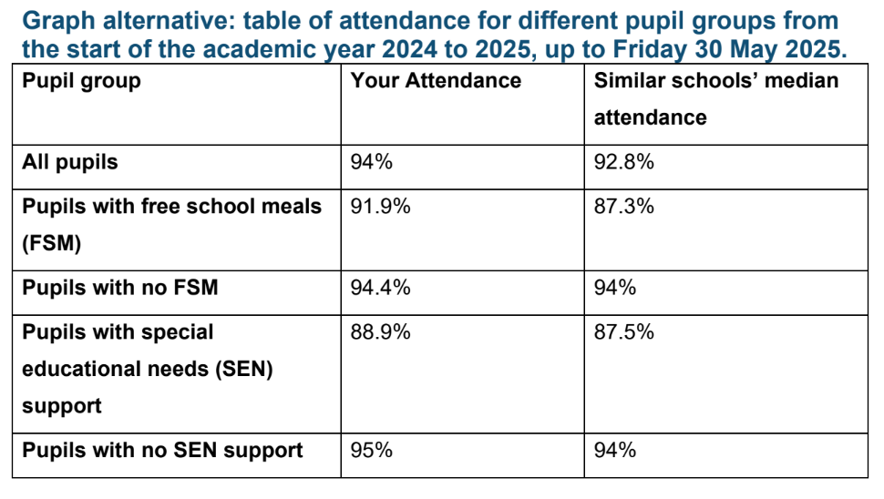  Our girls who are eligible for FSM attend school more than if they were to attend similar comparable schools. According to DfE 'Similar Schools Attendance Comparison Report' for the first half of the Summer Term 2024/2025 (Years 7 to 11) our FSM attendance: 91.9% - this is the highest of all comparator schools (median 87.3%).  FSM6 students at Northampton School for Girls have a year-to-date attendance rate of 91.4%, which is 5.2 percentage points higher than the national average for FSM6 students (86.2%).  Compared to all girls in the school, who average 93.6% attendance, FSM6 students are 2.2 percentage points lower, showing a small but notable attendance gap within the school.  Nationally, all pupils’ attendance stands at 91.3%, meaning that while FSM6 students at NSG attend less regularly than non-FSM6 peers in the school, they are still performing above national figures overall (FFT Aspire, August 2025).

Summary
The outcomes for our Pupil Premium students this year demonstrate steady and sustained progress, reflecting the positive impact of our targeted support. This improvement highlights the effectiveness of our interventions and the dedication of both staff and students in creating an inclusive and supportive learning environment.
We are encouraged to see the gap between pupil groups continuing to narrow, evidencing our ongoing commitment to equity and excellence for all learners. Strong attendance remains a particular strength, and through high quality teaching, alongside a clear focus on knowing and supporting each individual student, we are confident that progress will continue, especially in securing strong passes in English and Maths.

6 Year Trend in PP Outcomes
Progress 8 PP | 2020 = 0.13 (Gap= 0.31) CAG | 2021 = 1.18 (Gap =0.07)  TAG | 2022=0.2 (Gap= 0.48) Adjusted | 2023=-0.34 (Gap= 1.01) | 2024 =0.08  (Gap= 0.41) | N/A
Ebacc entry PP (Non PP) | 2020 36.1 (50.5%) | 2021 44.4% (51.6%) | 2022 30% (62.1%) | 2023 43% (54%) | 2024 = 85.7%  (91.1%) | 2025 = 85.4%  (90.3%)
Attainment 8 PP | 2020 =46 ( Gap= 11 )  CAG | 2021=56(Gap= 6)  TAG | 2022=45.9 (Gap= 12.87) Adjusted | 2023=39.3 (Gap= 17.1) | 2024 = 41.8  (Gap = 11.6) | 2025 = 42.64  (Gap = 12.2)
Percentage of Grade 5+ in English and Maths | 2020= 39% (Gap=16%) CAG | 2021= 53.7% (Gap= 14%) TAG | 2022 =37% (Gap= 26.3%)  Adjusted | 2023 =23% (Gap= 38%) | 2024 = 23.8%  (Gap = 30.5%) | 2025 = 18.8%  (Gap = 34.2%)
Ebacc 5+ | 2020= 13% (Gap = 12% ) CAG | 2021=25.9% (Gap = 9% )  TAG | 2022 =24.5 (Gap =24.4%) Adjusted | 2023 =11% (Gap =24.4%) | 2024 = 14.3%  (Gap = 25.7%) | 14.6%  (Gap = 24.2%)

Externally provided programmes
Please include the names of any non-DfE programmes that you used your pupil premium to fund in the previous academic year.
Programme | Provider
Accelerated Reader - with Star Tests | Renaissance Reading

Service pupil premium funding (optional)
For schools that receive this funding, you may wish to provide the following information: How our service pupil premium allocation was spent last academic year
In the academic year 2024–2025, we have had 14 students who are eligible for the service pupil premium funding. The funding has been utilised across the school to support the provision of our pastoral teams where we have five pastoral officers along with our safeguarding team. This ensures that additional support when required is available to all children of service personnel. The funding is also used to support counselling provision where required with our onsite counsellor.
The impact of that spending on service pupil premium eligible pupils
The progress of students of service personnel is in line with the school’s progress and this is expected to be maintained. Behaviour and attitude of this cohort of students is also very strong as a result of the support and the strong teaching they receive.

Further information

